The Traversers

VR Travel Application – Assignment 2

Travrse

Tyler Milbourne – 20827519

Kevin Kongo – 21473719

Justin Pan – 20977809

Caio Stirling – 20921770

Thursday, Group 2

Human Computer Interfaces ICTE 3002 / Advanced Human Computer Interfaces ICTE 5001

School of Electrical Engineering, Computing and Mathematical Sciences, Curtin University

Travrse

A Virtual Reality Travel Application



Contents

1 Wireframing 7

2 Low-Fidelity Prototype 8

2.1 Main Menu 8

2.2 Travrse Menu 8

2.3 Settings Menu 9

2.4 Planner Menu 9

2.5 Search Itinerary Menu 9

2.6 New Itinerary Menu 10

2.7 Search Itinerary 10

2.8 New itinerary 10

3 Expert Review 12

3.1 Performing Expert Review 12

3.2 Expert Review Analysis 12

4 High-Fidelity Prototype 16

4.1 Main Menu 16

4.2 Travrse Menu 17

4.3 Travrse Explore 17

4.4 Settings 18

4.5 Planner Menu 19

4.6 New Itinerary Menu 19

4.7 Search Itinerary Menu 20

4.8 New Itinerary Explore 20

4.9 Search Itinerary Explore 21

4.10 Itinerary Pop-up Menu 21

4.11 Design Specifications for Handoff 22

4.11.1 Menus 22

4.11.2 Icons And Logo 22

5 Alterative High-Fidelity Prototype 25

5.1 Introductory Screen 25

5.2 Search Itinerary Menu 25

5.3 Search Itinerary Info 26

5.4 New Itinerary Menu 26

5.5 Travrse Menu 26

5.6 Account Menu 27

5.7 Settings Menu 27

5.8 Search Itinerary Explore 27

5.9 New Itinerary Explore 28

5.10 Travrse Explore 28

6 Usability Testing Plan 30

6.1 Research Goals 30

6.1.1 User aspects 30

6.1.2 System aspects 30

6.1.3 Priority table 31

6.2 Experimental Setup 31

6.2.1 Equipment Needed: 31

6.2.2 Software 31

6.2.3 Location 31

6.2.4 Controlled Variables 31

6.3 Facilitator 32

6.4 Task Scenario and Tasks 32

6.4.1 Pre-Test Questionnaire 32

6.4.2 Tasks 32

6.4.3 Post-Test Questionnaire 32

6.5 A/B Testing 33

6.5.1 Prototype A 33

6.5.2 Prototype B 33

6.6 Participants 34

7 Piloting 36

7.1 Study Objective 36

7.2 Key Data Points 36

7.3 Informing Researchers and Deployment 36

7.4 Pilot Result Evaluation 36

8 Experimental Data collection 36

8.1 Collection Focus 36

8.2 Collection method 36

9 Analysis of usability testing report 37

9.1 Participant Profiles 37

10 Final High fidelity prototype design 39

10.1 Adding to/Removing from Itinerary (Initial Version) 39

10.2 Adding to/Removing from Itinerary (Final Version) 41

10.3 Layout, Size, and Colour 43

10.4 Trading hours 44

10.5 Point of Interest Markers 47

10.6 Itinerary Planner View 47

10.7 Viewing the itinerary 48

10.8 Layout and size 49

10.9 Colour changes 50

11 Final High-Fidelity Prototype 52

11.1 Introductory Screen 52

11.2 Search Itinerary Menu 52

11.3 New Itinerary Destination Menu 53

11.4 Travrse Menu 53

11.5 Account Menu 53

11.6 Settings Menu 54

11.7 Search Itinerary Information Menu 54

11.8 New Itinerary Menu 54

11.9 Search Itinerary Explore 55

11.10 Travrse Explore 55

11.11 New Itinerary Explore 56

12 Project Management 64

12.1 Meetings 64

12.2 Risk Management 65

12.3 Problems Encountered 66

13 Conclusion 68

14 References 69

15 Appendix 71

Appendix A: A User Survey Responses 71

Appendix B: ChatGPT 77

Appendix C: Expert Review 78

Appendix D: Meeting Minutes 79

Appendix E: Contribution Table 79

Appendix F: Figma Files 79



Low-Fidelity

Prototyping

01

02

# 1 Wireframing

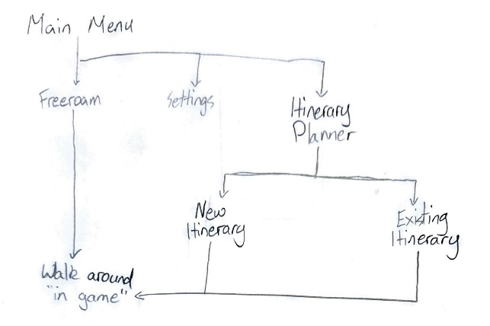The first stage of the design process for our team was drawing up some basic wireframes. The purpose of these wireframes is to allow us to get a good idea for how the application will be structured, without spending too much time on small details so we can make small iterations if needed.

We started by simply drawing a pseudo flowchart in order to get a rough idea for how the app would be structured (pictured to the left).

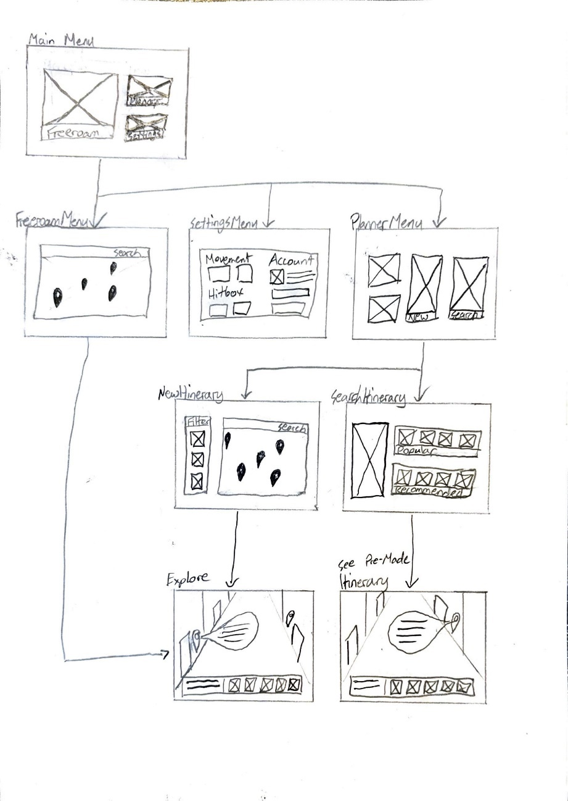The next stage was to draw the actual wireframe. Since we were still only working on the wireframes, we wanted to keep it as simple as possible, while still displaying the general structure of the application.

The main idea behind each frame:

* Main Menu:  
  Has options to go to free roam, the planner menu, and the settings menu.
* Free Roam Menu:  
  Displays a map with pinpoint of major points of interest within the selected area.
* Settings Menu:  
  Contains all of the necessary settings for users to adjust.
* Planner Menu:  
  Give users the choice between creating a new itinerary and looking at existing ones.
* New Itinerary Menu:  
  A map with pinpoints marking all of the main points of interest with filters on the side
* Search Itinerary Menu:  
  Allows users to search through pre-made itineraries
* Explore:  
  Allows users to explore the area that they selected by jumping to different points of interest and having the option to add to their current itinerary.
* See Pre-Made Itinerary:  
  Operates the same as the explore screen, but for pre-made itineraries.

# Low-Fidelity Prototype

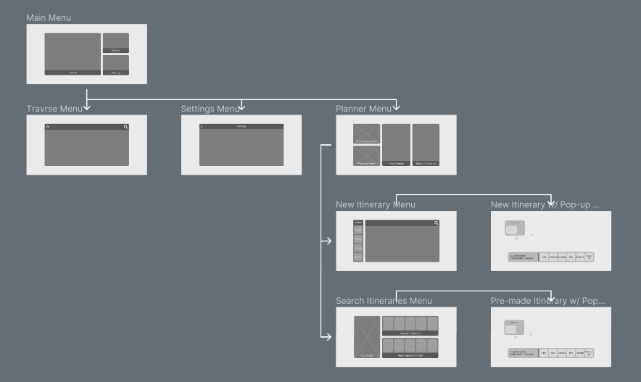After finishing the wireframes, the next step is the low-fidelity prototype. Similar to the wireframes, the low fidelity prototype is not meant to be overly detailed. In addition to the basic structure shown in the wireframes, the low-fidelity prototype also shows the specific layout of each page, including the specific placement of buttons and icons. To the right is a screenshot of the entire low-fidelity prototype:

It follows the structure of the wireframes almost exactly, with the only change being that the Travrse menu (previously the free roam menu) no longer links to the explore screens.

## Main Menu

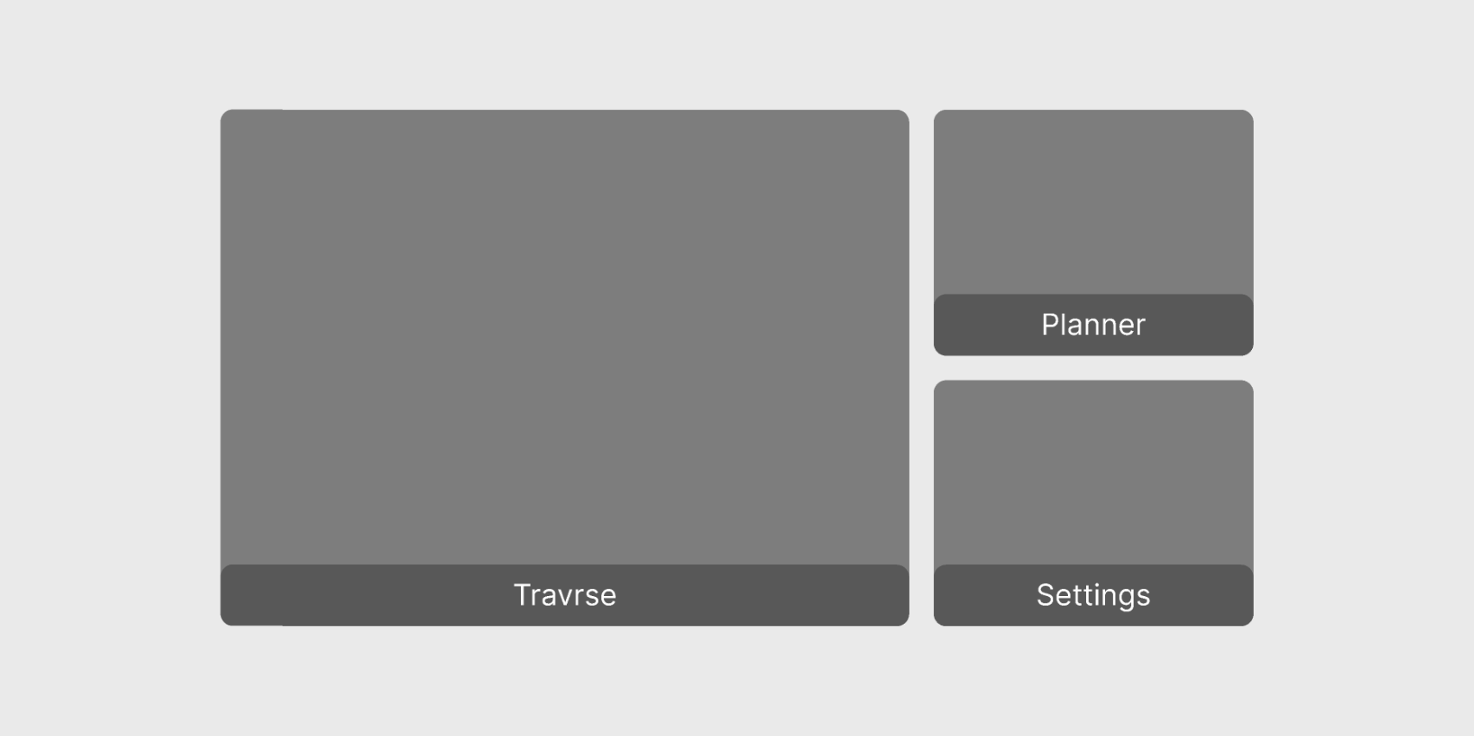The main menu looks almost identical to the wireframes, simply having the same three large buttons that take up the entire menu. The only difference here is the renaming of the free roam menu to Travrse. Since this is the first menu that users encounter within the app, we want it to be simple and easy to understand. This is to prevent users from being intimidated when they first use the application.

## Travrse Menu

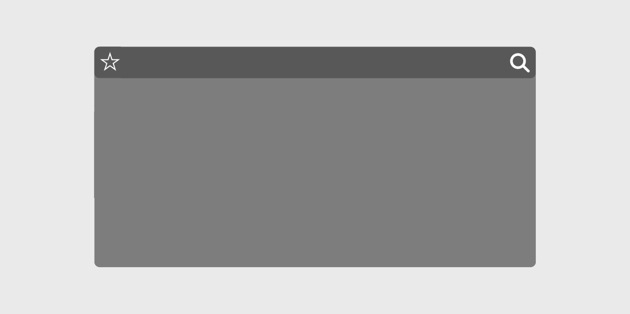The Travrse menu operates by displaying a map in front of the user with pinpoints marking points of interest. The search button allows users to go to specific locations. There is also a favourite button that will save the users favourites to view later.

## Settings Menu

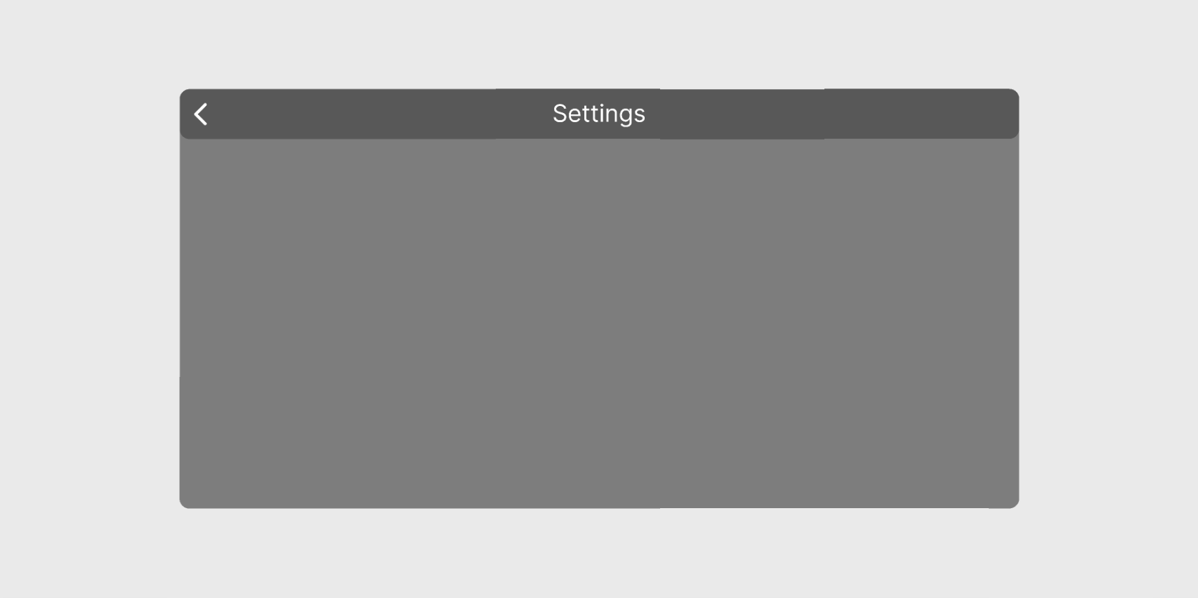The settings menu has been left blank for the low-fidelity prototype in order to leave room for us to add what we need after talking to potential users about what they would like to see.

## Planner Menu

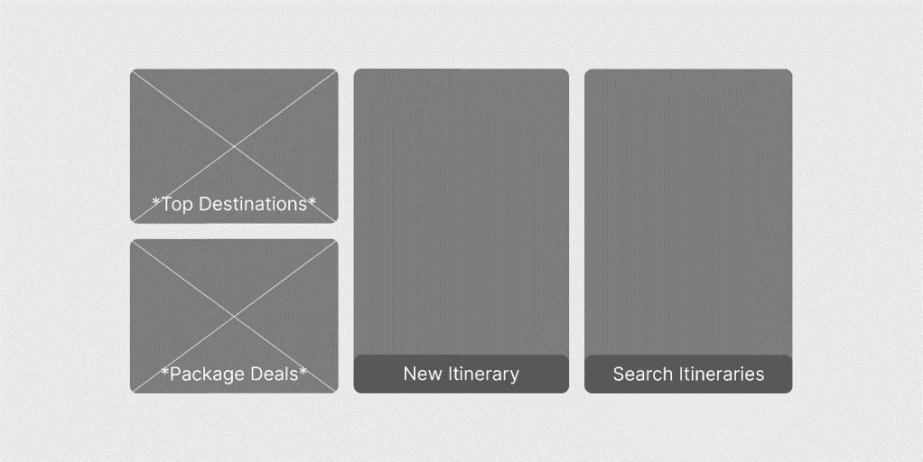The planner menu contains four elements which in the form of two buttons and two scrolling galleries. The new and search itinerary buttons both link to their respective pages and will simply display pictures of different locations. The other two elements on this page are the scrolling galleries named ‘Top Destinations’ and ‘Package Deals’. The top destinations gallery scrolls through some of the most popular destinations at the current time. The package deals gallery scrolls through pictures of destinations that travel agents are currently promoting in package deals.

## Search Itinerary Menu

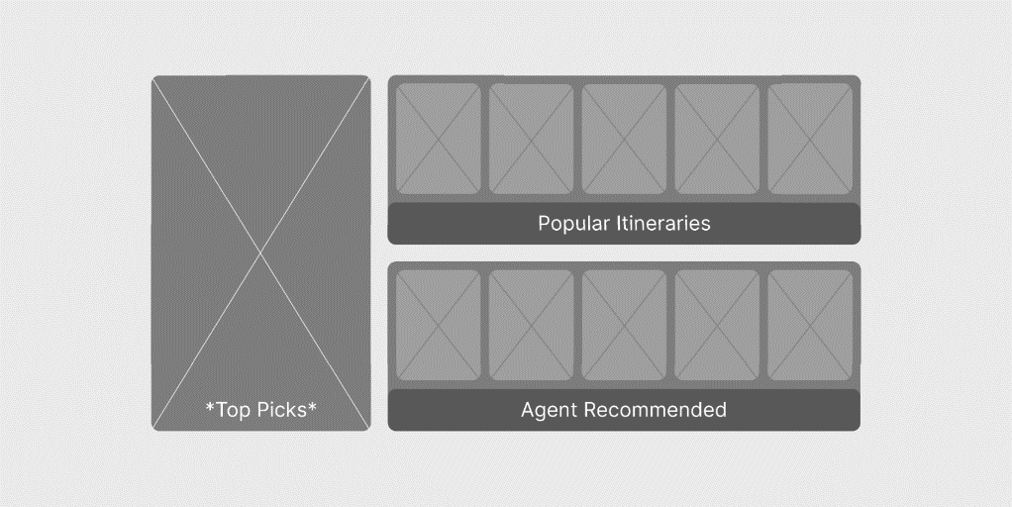The search itinerary menu contains two submenus and a scrolling gallery. The popular itineraries submenu displays a rotation of the most popular itineraries with other users, and the agent recommended submenu does the same but displays itineraries recommended by travel agents. The top pick scrolling gallery simply displays photos of some of the most travelled to destinations on rotation.

## New Itinerary Menu

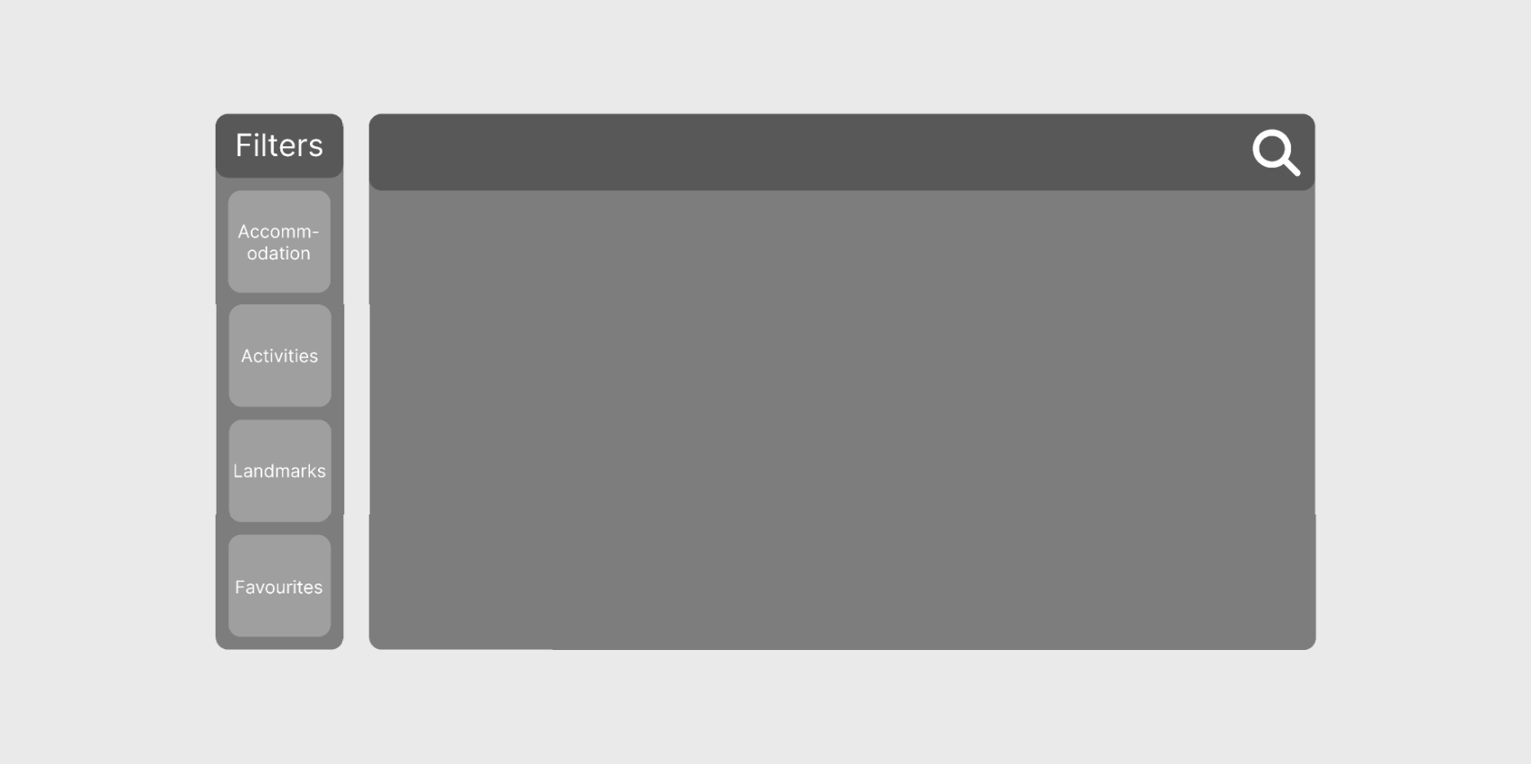The new itinerary menu displays a large map similar to the Travrse menu, but it also has a filters menu on the side. The filters menu allows users to toggle exactly what pinpoints they want to see on the map, allowing them to focus on specific areas of their itinerary. In order from top to bottom, the filters are for accommodation, activities, landmarks, and favourites.

## Search Itinerary

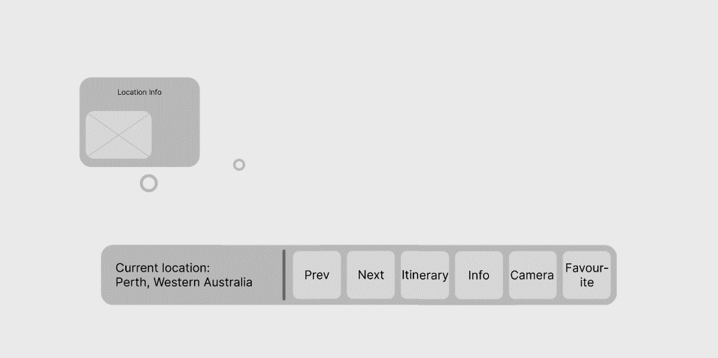The search itinerary page is everything that occurs within the VR world when users select to view pre-made itineraries. It includes a simple navigation menu at the bottom with options to go the next point of interest or the previous one, view the entire itinerary, see key info about the current location, take pictures of the current area, and favourite the current location. There is also a pop menu when users click on the pinpoints that hover outside certain points of interest that display key information about them.

## New itinerary

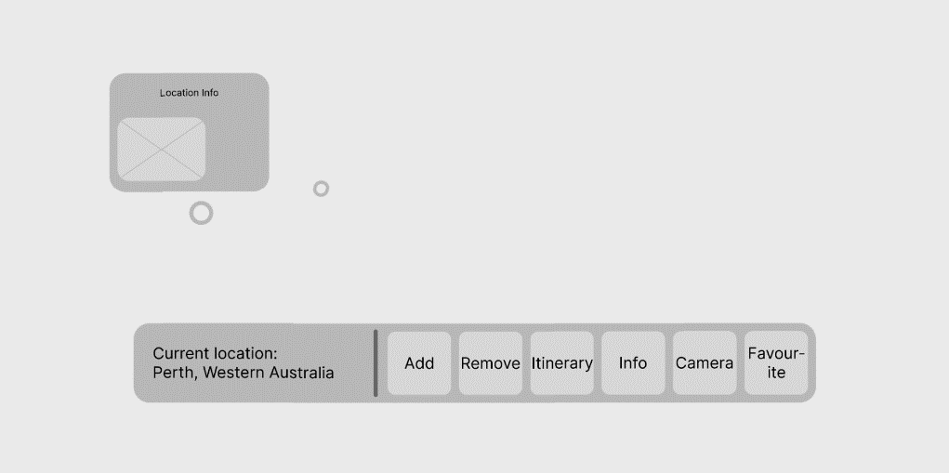The new itinerary page is the same as the search itinerary page, but it has the options add and remove the currently viewed point of interest to the itinerary, since this page is accessed by creating a new itinerary.



03

Expert  
Review

# Expert Review

## Performing Expert Review

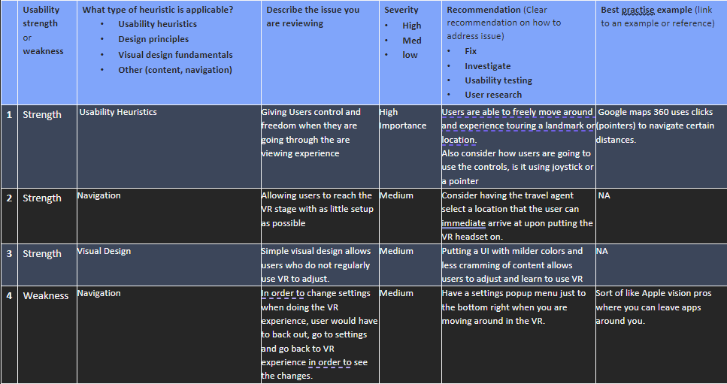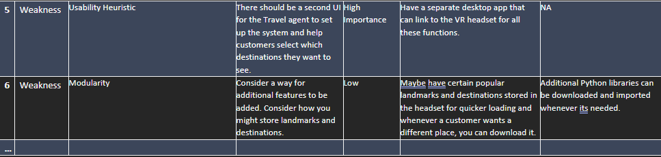The following is the expert review that we had received from another group during tutorial 5.

## Expert Review Analysis

From the expert review, one of our biggest strengths from our lo-fi prototype was giving the users control and freedom in the viewing experience. This is one of the main goals of Travrse as we want to allow users to explore the area that they will be travelling to, to make an informed decision as to whether or not they want to travel to that destination.

Hearing that we have achieved this in our initial lo-fi prototype is very encouraging, and we will continue with how we approach and implement the controls in Travrse.

The feedback that we had gotten for this aspect was to consider and clarify as to how the users would control their movement in the application. After talking with the expert review group, we realised that it would be important to include different types of controls for different demographics, for the younger and more mobile demographic, they might go for a more immersive experience, whilst the older and less mobile demographic may not be as physically active or mobile, and may opt for a joystick control.

This consideration will greatly increase our usability, user experience and accessibility factors and we will include this in our hi-fidelity prototype (a way to toggle controls) as we move forward.

Another strength that we were told we had by the expert review group, is in our navigation of the UI, saying that we allow users to reach the VR exploration stage with minimal set-up, allowing for a seamless user experience.

A consideration that we have been told which we may include, is how we can get the travel agent that is assisting this customer, to place the user in their selected location for them via an alternate window on their computer, allowing for a more seamless experience and further minimising the initialisation process.

We believe that this is a good consideration as for a large proportion of users who are not used to VR applications, typing and searching using VR peripherals may still be a bit unnatural, and using or having the travel agent set the user up from their computer provides a cleaner experience to the end user, making the most of existing and new systems.

Of the 3 strengths that we were told we had, the last strength was how simple and minimalistic our user interface was, saying that this was a strength as it allowed for users who aren’t used to VR to get familiar with the interface quicker. This is also good to hear as we do not want users to be struggling and getting frustrated in trying to learn how to operate Travrse, as we want users to focus on exploring cities and locations, rather than focusing on how to use the system.

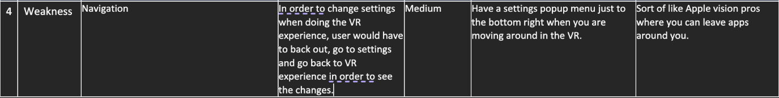A recommendation that we have been told is to use milder colours in the user interface and experiment with different layouts to reduce cramming of elements. This is something that we will take into consideration as we move forward with our hi-fidelity prototype and decide if we can find an alternative layout that improves the user experience this way.

One of our weaknesses that was highlighted by our expert review group is the number of steps currently required by the user to go and change settings. In our current rendition of the lo-fi prototype, users need to go back to the main page to access settings. If users are currently exploring their destination in VR, then they will be required to go back 3 menu screens to get to the main page.

For users of any technical level, this can be very frustrating, especially if they are using the system for the first time and want to customise their setting. As a result, this reduces the ease of use, and does not make the application enjoyable to use. Taking the expert group’s recommendation of having a popup menu in the bottom right, or any particular corner would be useful to have as users can immediately navigate to their settings if they find that anything feels ‘off’ or they need to adjust controls or settings.

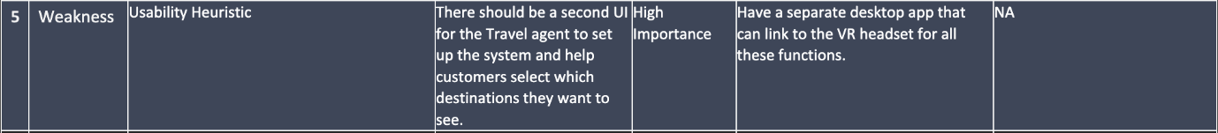This in hindsight seems like something very obvious to include, and we will definitely be implementing this in future iterations of the high-fidelity prototype. We might not include this in the bottom-right corner specifically, or have it as a constant window like in the Apple Vision Pro OS, however, definitely keeping the settings option only one button click away would be optimal and a good design choice moving forward.

One feature that is a part of Travrse is to have the travel agent that is helping the user with the VR headset assist with certain functions. Travrse is a virtual reality travel tool that can help users find and plan their dream holiday destination. This being said, we had not drafted up a low-fidelity prototype for what the travel agent’s user interface would look like. Since the travel agent’s interface would look slightly different due to it being on a desktop computer rather than a VR headset, this is something that we should include and we had tunnel visioned on getting the VR interface perfect, that we forgot to make the interface for the travel agent.

This is advice that we will definitely put into practice, and aim to get implemented as we move forward with our high-fidelity prototypes.

The final weakness that was highlighted by our expert review group is to have certain popular places and destination to be pre-loaded. This is quite a good recommendation as it would significantly reduce load times for popular destinations that people wish to go to. By having a set of popular locations pre-downloaded into the VR Travel Application would be ideal, it would not be feasible to have a highly detailed 3D model of the whole world, but rather zones/locations that we would include in our travel application and only downloading specific locations that have 3D models available, but are rarely used.

Otherwise, the space required by the application would be too large, making it a very resource intensive application. However, having certain popular travel destinations pre-downloaded will reduce these load times, this is good to include, however I believe this would be more of a higher priority concern when it comes to development of the application and won’t be as applicable as the rest of their feedback in making our high-fidelity prototype.



04

High-Fidelity

Prototyping

# High-Fidelity Prototype

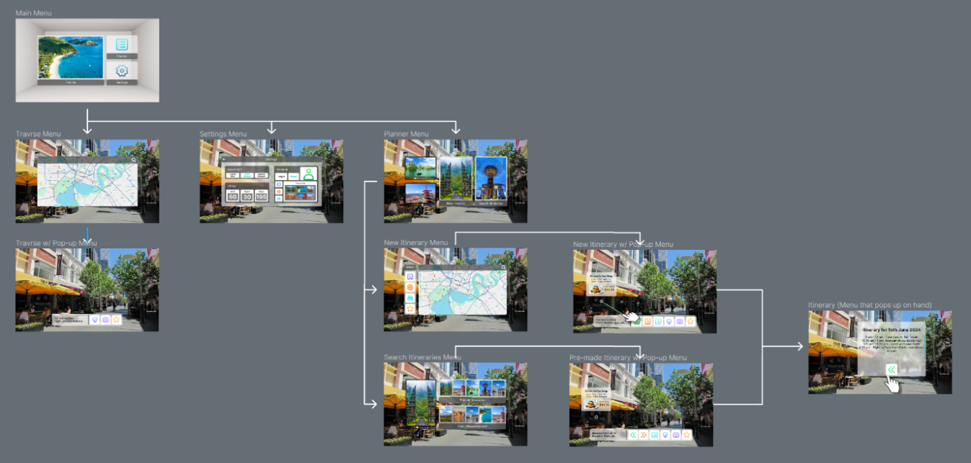With the low-fidelity prototype out of the way and having received feedback on the design, the next step is to move on to the high-fidelity prototype. Below is a screenshot of the entire high-fidelity prototype, it follows the design of the low-fidelity prototype but with the addition of an extra exploration screen and a designated itinerary screen.

## Main Menu

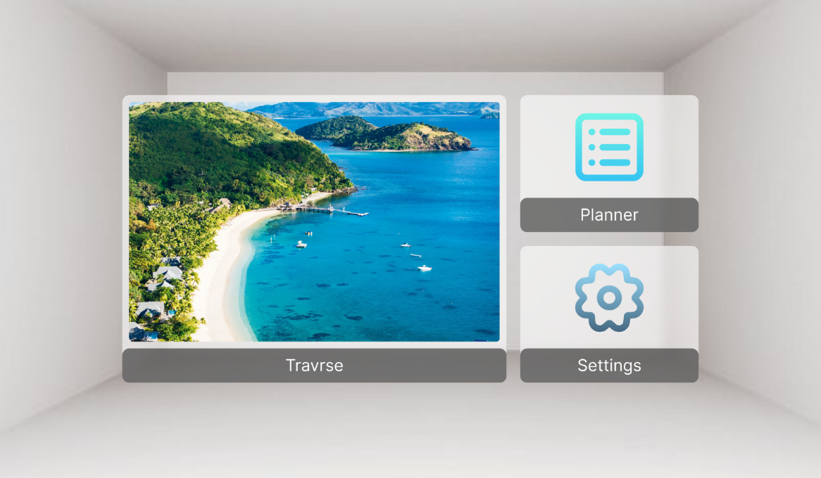The main menu has retained the same core design as what was shown in the low-fidelity prototype. The image on the Travrse button will rotate to a new image whenever the user enters the page again. Icons are used for the planner and settings buttons for simplicity’s sake. The background shown in the prototype is simply meant to represent how when the user first launches the application, they will be in an empty room with the main menu in front of them. If the user later accesses the main menu while exploring, the main menu will simply display over their current location rather than transporting them back to the empty room.

## Travrse Menu

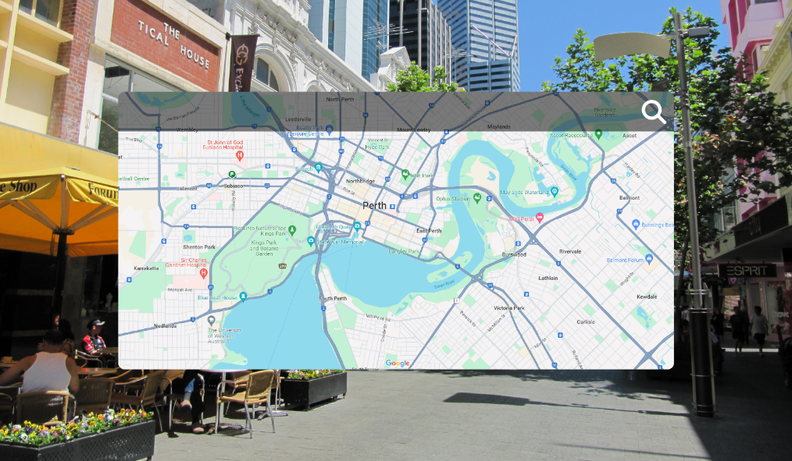The Travrse menu remains just as simple as in the low-fidelity prototype, consisting of a large map and a search icon. The search icon allows users to search for specific locations and points of interest, therefore allowing them to freely explore the world.

## Travrse Explore

The Travrse explore screen is a very simplified version of the exploration screens found in the create and search itineraries sections. The navigation bar contains the current location of the user, an information button for display key information about the location, a camera button to take pictures of what the user is currently looking at, and a favourite button that allows users to save their current location to their favourites to view later. We want this menu to remain simple as it is meant to be a way for the user to freely explore the world without needing to create a new itinerary or search through existing ones.

## Settings

The settings menu in is no longer empty as it was in the low-fidelity prototype. The menu is broken down into three individual sections, those sections being movement, hitbox, and account.

The movement submenu allows the user to select their preferred method of movement, with the highlighted option being the one that is currently in use. Control stick allows the user to move by moving the control stick on their controller, quick teleport allows users to instantaneously teleport to the location that they are pointing at, and smooth teleport is the same as quick teleport but it fades to and from black and is much slower, making the experience more comfortable for users who prefer it.

The hitbox submenu contains options to change the width, depth, and height of the user’s hitbox. This means that users can adjust their hitbox in the application to match their own statue. One great example of how this could be very useful is users who use a wheelchair to see if they will fit in certain areas, such as through doors within their accommodation.

The account submenu has a login section at the top, which contains a login button, a guest button, and a profile picture. The guest option will allow users to still access features such as favourites, but they will only be available for the current session. Users can opt to login later and save the data that is saved on the current guest mode session.

Finally, the favourites submenu simply displays all of the accommodation, activities, and landmarks that the user has marked as a favourite. The menu also contains filters on the side to show or hide each of aforementioned options.

## Planner Menu

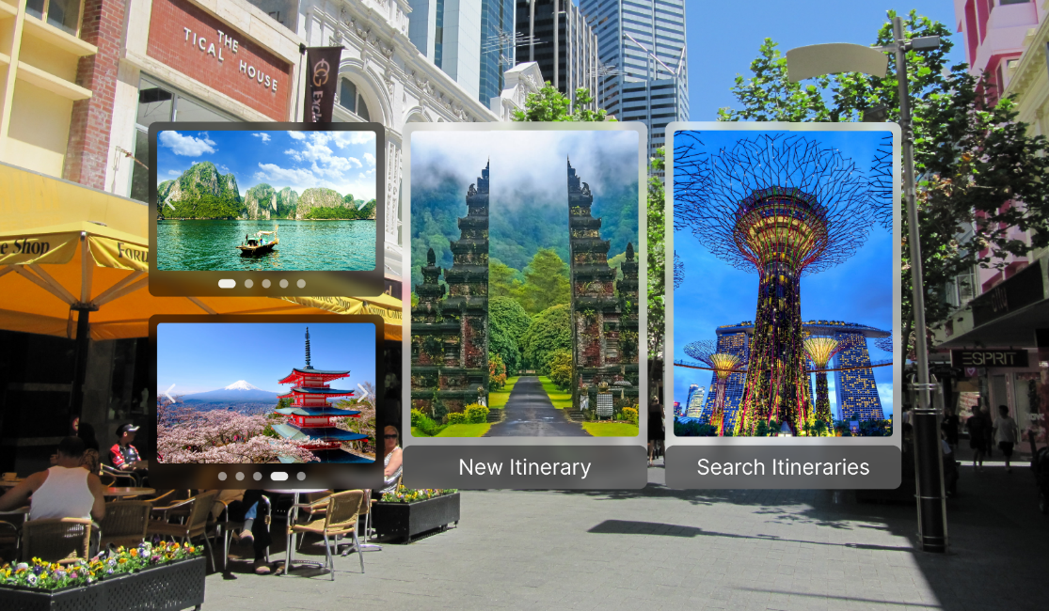The planner menu remains the same as in the low-fidelity prototype. It simply contains two buttons, directing the user to either create a new itinerary or search through existing ones. There are also two scrolling galleries on the left showcasing some of the most popular destinations at that current time.

## New Itinerary Menu

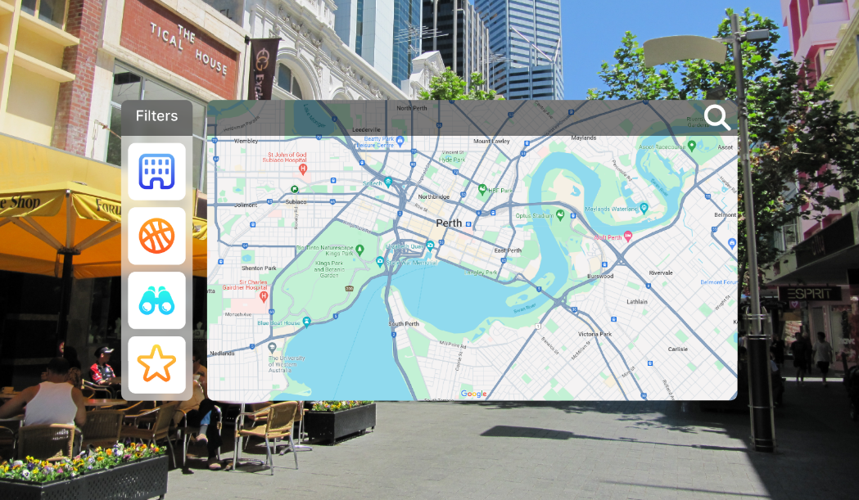The new itinerary menu also remains the same as in the low-fidelity prototype, containing a large map with filters on the left.

The map functions much the same as the one seen on the Travrse menu, with the addition of pin points thanks to the filters seen on the left-hand side.

The filters submenu contains four buttons, those buttons being accommodation, activities, landmarks, and favourites. Each of these options is a toggle to show or hide pin points for their respective points of interest. If the user is in guest mode, the favourites will display whatever the user has favourited within the current section, if they have done so.

## Search Itinerary Menu

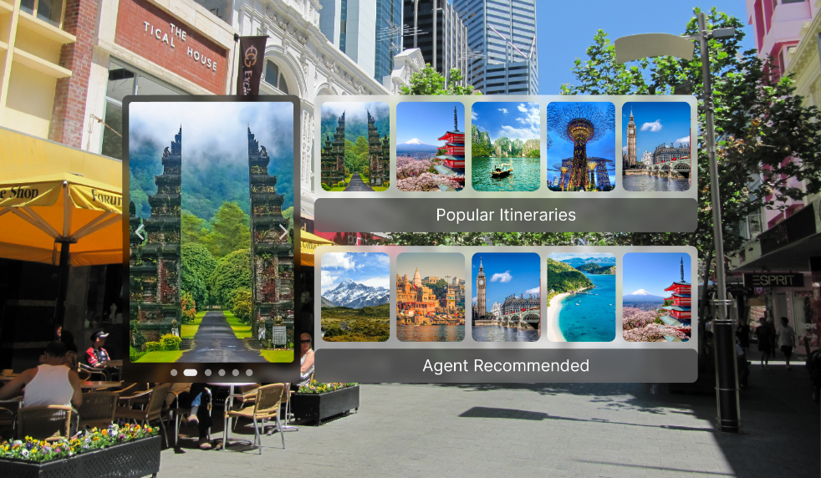The search itinerary menu remains unchanged, featuring the two submenus for popular and agent recommended pre-made itineraries, with a scrolling gallery on the left that showcases images of some of the most popular destinations.

## New Itinerary Explore

The navigation bar for new itinerary explore screen also remains the same. The current location is displayed on the left, with the six buttons on the left being used to add and remove points of interests from the user’s itinerary, view the itinerary, show information about the current location, take pictures of the current location, and add the current location to favourites.

## Search Itinerary Explore

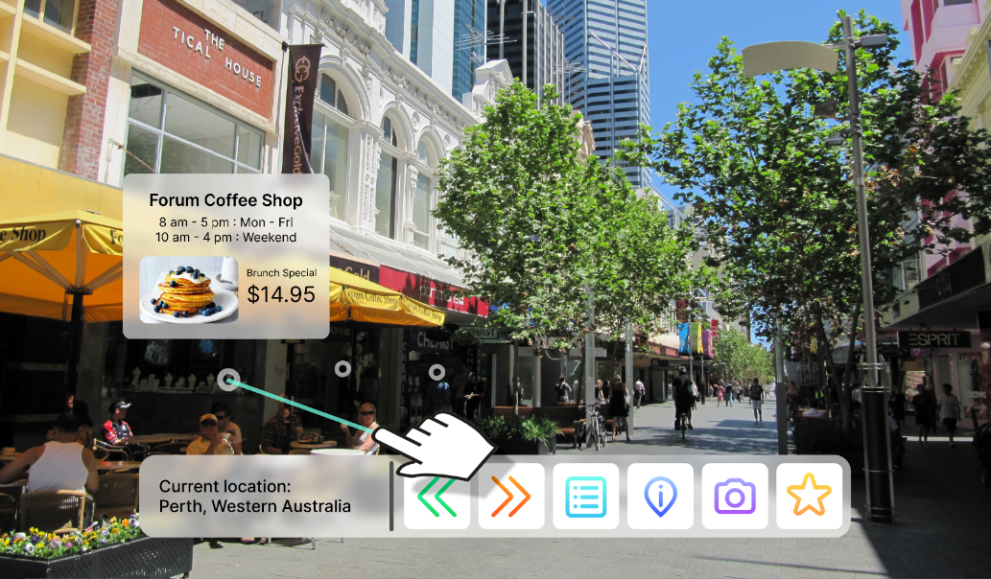The search itinerary explore screen is most the same as the new itinerary screen, but with the add and remove buttons replaced with previous and next buttons to scroll through the pre-made itinerary. We also included pinpoints on some of the stores with a pop-up menu to showcase what it would look when the user interacts with points of interested around them.

## Itinerary Pop-up Menu

This additional screen is meant to showcase what the pop-up menu would look like when users view their itinerary while exploring. It is a simple interface that is just meant to show the user details on the locations they have selected, along with what details about the time they take place and what they will be doing.

## Design Specifications for Handoff

The design of the Travrse application is quite simple, following a small handful of rules in order to maintain coherency.

### Menus

The menus all use the same design principles so they remain coherent. These principles are:

* Menus have rounded corners with a 20px corner radius.
* Menu elements (such as buttons) have rounded corners with a 10px corner radius.
* Menus are created a main ‘background’ panel and a title/navigation panel. The background panels are white (#FFFFFF) set at 60% opacity, and the title panel is black (#000000) set at 50% opacity.
* Menu panels all have a background blur effect set to 15.
* All menu buttons are white with the icons directly centre.
* Text over the white panels is black (#000000) and text over the black panels is white (#FFFFFF).
* Scrolling galleries have a black (#000000) background panel set to %50 opacity.
* The font used for all text is a modern sans serif font, no specific font is required (needs to be universal though).
* All Icons are coloured using a linear gradient with the lighter colour on the top and the darker colour on the bottom. The colours for these icons do not need to be specific, but they do all somewhat relate to what colours people would associate with each icon respectively and need to be different enough to stand out from one another.

### Icons And Logo

The Icons for our application are all custom made to fit the aesthetic of the application. They all follow the same design principles, like the menus, in order to achieve coherency. These principles are:

* Icons all roughly fit within a 35px x 35px square.
* Icons are all stroke-based icons with minimal if any fill.
* Icons all use a 3px thick stroke at that scale.
* Icons all use rounded corners.

Once the icons are created at the smallest scale, they are then scaled up by 1.6x to get the main size that is used within the navigation bars and filter menus.

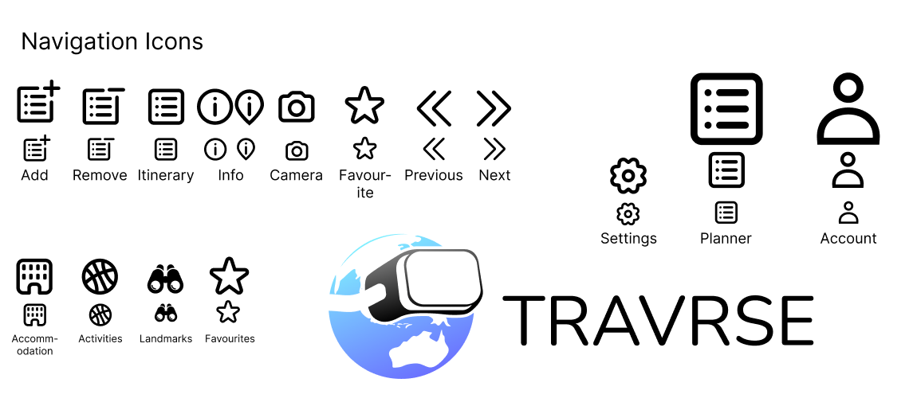The base icons are shown below:

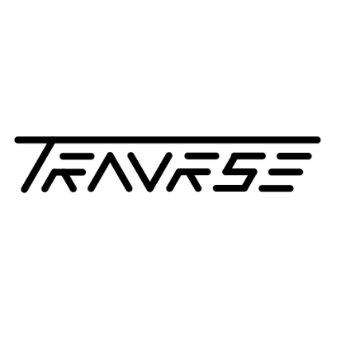The logo design started with three initial ideas. Simple version of those ideas were created and the group universally decided on which they liked the most.



The Team universally agreed on the first logo, and so it was redesigned to create what we have settled on for our final logo.

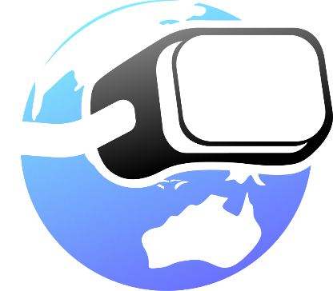This logo represents our product in many ways. The simplistic overall design reflecting the simplicity of our application, the inclusion of the globe to invoke the sense of adventure and wanting to explore everything that the world has to offer, Australia being a central focus of the globe (below the headset), and the headset sitting in such a way that it looks as though the globe is looking off into the distance with wonder. All of these factors represent our group and the product that we are creating.



Alternative

Prototype

05

# Alterative High-Fidelity Prototype

Before conducting our usability tests, we are creating an alternative version of the original high-fidelity prototype. The purpose of this alternative version is to try new ideas, such as a different form of navigation. As part of the usability testing, we then give half of our participants the original prototype and the other half the alternative version. Splitting the testers in half with which version they use will give us some insight into which design is better for usability and therefore which design to move forward with and into the final prototyping stage.

## Introductory Screen

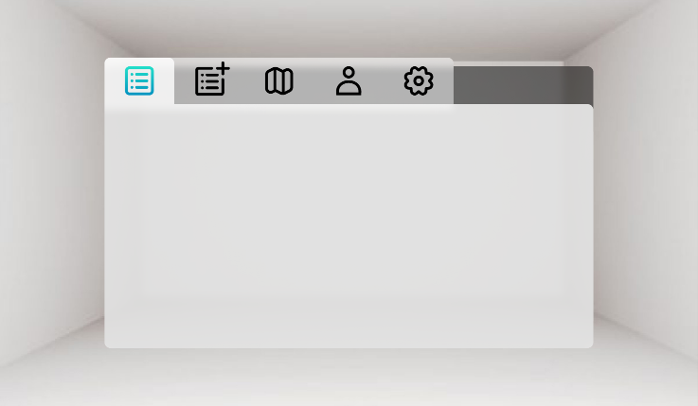The first thing we added was an introductory screen for when the app starts up. The main idea behind this screen is to show that when the user first enters the app, either we will use the VR headset’s passthrough feature to display the world around the user behind the menu. For VR headsets that do not have such a feature, we will instead display a plain room behind the menu. The idea behind this is to help ease users into the VR experience, since a lot of our potential users will be new to VR. We intentionally left the menu blank for this screen and it would simply be used while the headset is loading, once the app is loaded and the use starts the interact with the menu, the background will change to something more relevant, being a randomly chosen travel destination. This introductory screen also provides the first look at our new menu design for the alternative prototype. Rather than using multiple floating menus like the original design, this design uses a single menu with tabs at the top to switch between all of the main menu options. This menu design should be much less confusing to any newer VR users as it feels much closer to standard menu navigation that you would find on apps found on computers and mobile devices.

## Search Itinerary Menu

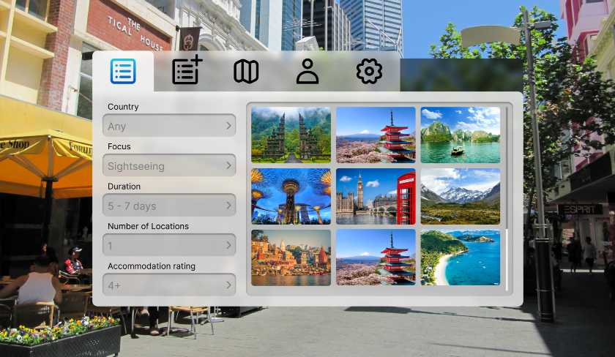The search itinerary menu gives the user five separate filter options to help find a pre-made itinerary that closely matches the kind of holiday they are trying to plan. The scrollable menu on the right displays cover pictures for the pre-made itineraries that can be clicked by the user, sending them to a menu that explains the itinerary in more depth.

## Search Itinerary Info

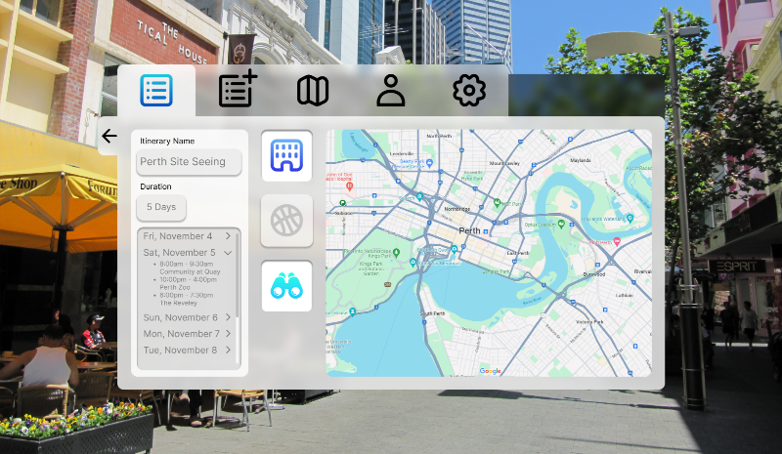The search itinerary info menu is what is displayed when users click on the pre-made itinerary images on the previous menu. On the left, there is an information tab that displays the name of the itinerary, the duration, and the itinerary itself underneath. The itinerary section shows all of the individual days for the itinerary, with a drop-down menu that users can click to reveal all of the activities and the times in which they are planned for. To the right of this is a map with some filters. The map displays all of the activities on the itinerary list as pin points so the user can see where they are located. The buttons on the left of the map are togglable and determine which pin points are shown. The colours of the pin points match the colours of the button icons when they are toggled.

## New Itinerary Menu

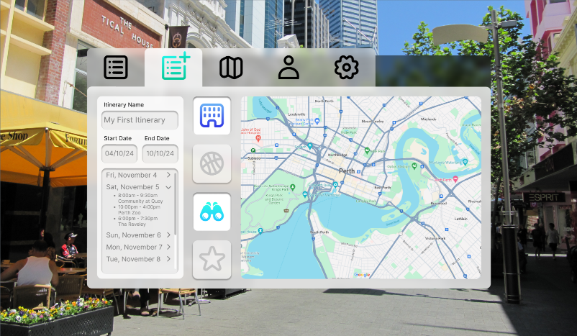The new itinerary menu is similar to the search itinerary info menu, but it also allows users to edit the itinerary. At the top of the side menu users can change the name of the itinerary, as well as the start and end dates. The filters also include a favourites button that can be used to show the user’s favourite activities and landmarks, making it easier to add them to their itinerary.

## Travrse Menu

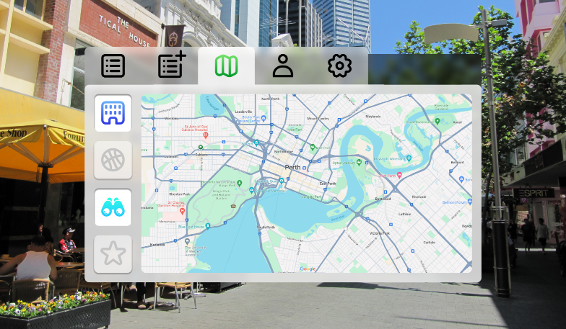The travrse menu is very simple. It contains a map similar to the one used in the previous two menus, functioning in the exact same way, but displaying all of the accommodation, activities, landmarks, and favourites in the area. Users can then click on the pin points to visit them.

## Account Menu

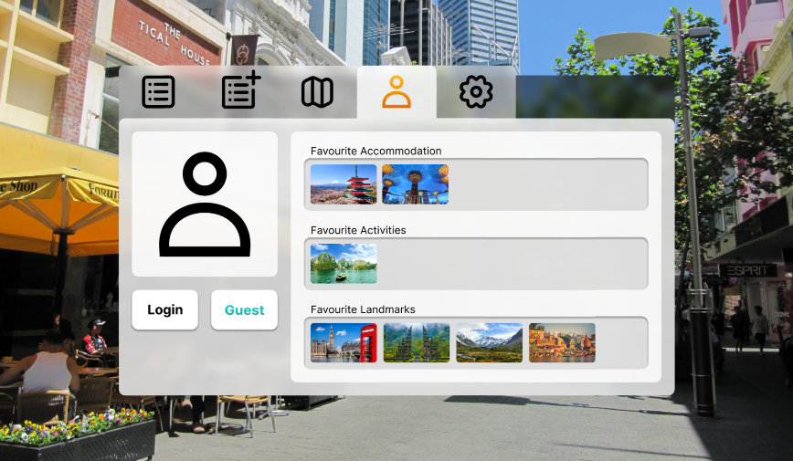As part of the redesign, we separated the account and settings menu into two distinct menus. The account menu has the option to login or continue as a guest, with the user’s profile picture above these options. Should a user choose to continue in guest mode, they will still be able to save their favourites, but they will be erased once the current session is over. The favourites are displayed in scrollable menus on the right and separated into their respective categories. Users can click on the pictures to visit them.

## Settings Menu

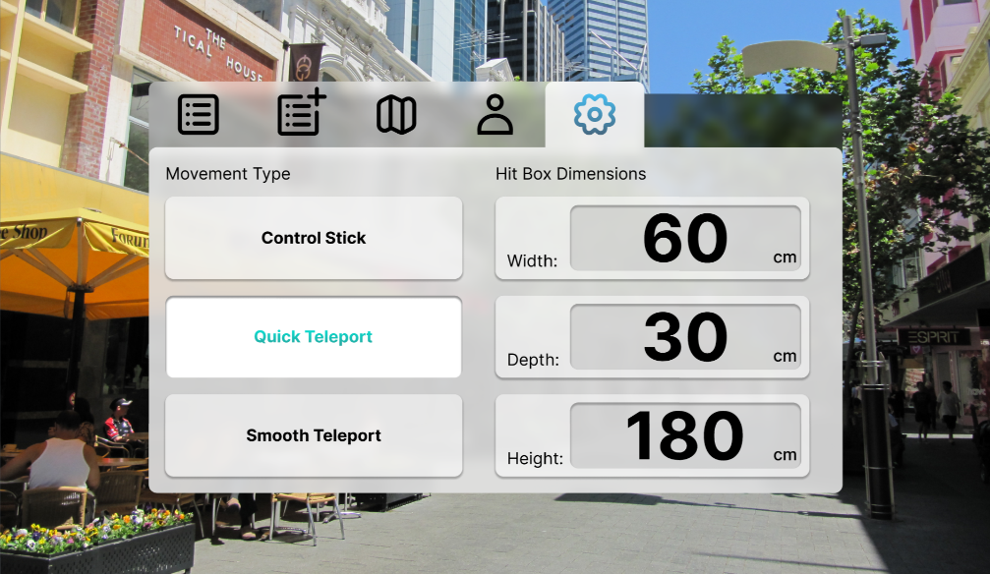The settings menu maintains the same options as on the original prototype, but enlarged so that they take up the entire menu. The type of movement is able to be selected via the buttons on the left, and the user’s hit box dimensions are able to adjust on the right.

## Search Itinerary Explore

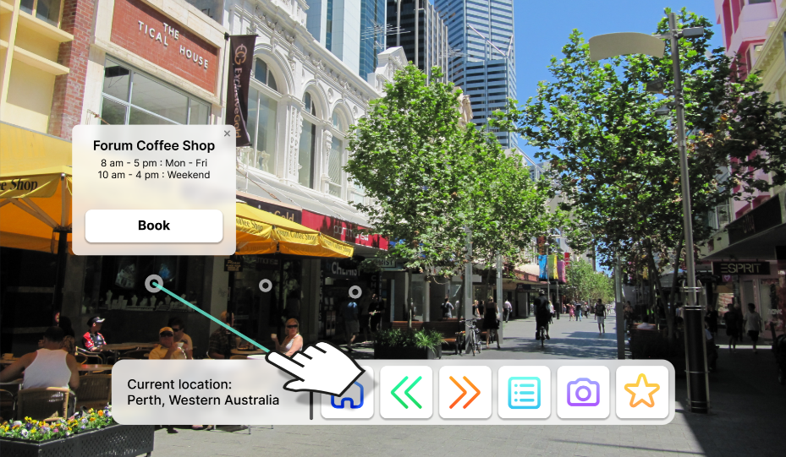The search itinerary explore screen is very similar to the one seen in the original prototype, but the information button was removed and replaced with the home button. The home button simply allows the user to bring the main menu back up from the navigation bar, making navigating to other parts of the itinerary faster.

## New Itinerary Explore

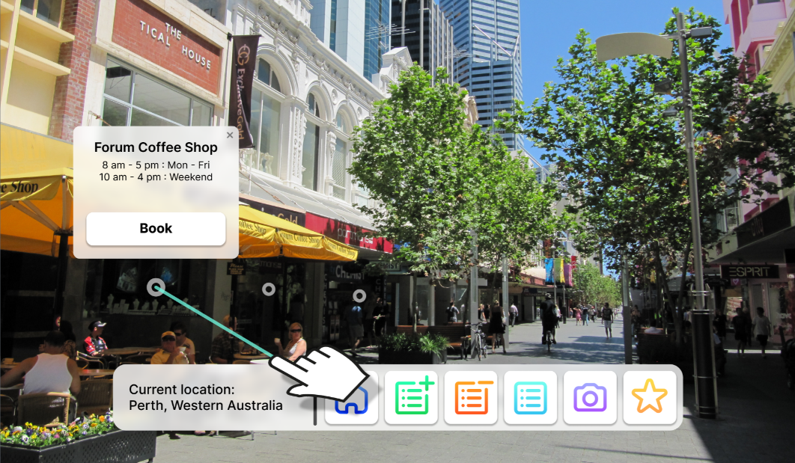The new itinerary explore screen, much like the previously shown search itinerary explore screen remains very similar to the original prototype, but now including the home button. The home button functions in the same way as it does in the search itinerary explore screen. The only difference between these two screens is the same as what was seen in the original protype, being the inclusion of an add button and a remove button instead of the next button and previous button used in the search itinerary explore screen to navigate pre-made itineraries.

## Travrse Explore

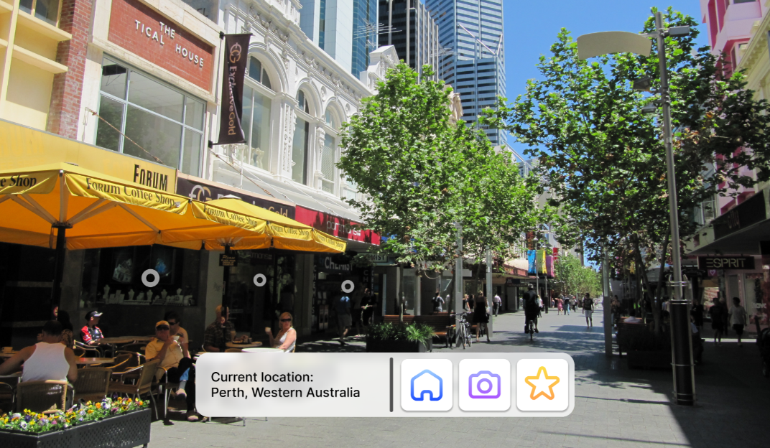The travrse explore screen also remains much the same as the original, but with the home button instead of the information button. The navigation bar on this screen is intentionally simple since the main point of the travrse explore screen to allow users to explore the world around them freely without needing to create a new itinerary or look at existing ones.



Usability

Testing Plan

06

# Usability Testing Plan

## Research Goals

### User aspects

* Saving a Point of interest to an itinerary
* Exporting an itinerary to a PDF document
* Viewing itineraries made by the user
* Viewing itineraries made by other users
* Viewing pricing details for accommodation, food spots and attractions
* Exploring a local area to search for points of interest

### System aspects

* Is the experience smooth and free from stutters and choppiness (these greatly deteriorate the quality of a VR experience)
* Is the experience provided at a high frame rate, to reduce the likelihood of VR induced nausea?
* A user may only use our application when planning a trip (so they don’t use it often). Does the user spend too much time learning how to use the application properly?
* Of our two Prototypes, which one allowed the user to engage with the Virtual Reality experience more? Which allowed them to more quickly and efficiently proceed to the primary function of the application?
* Are pricing and deals, especially from potential business partners, made clearly visible to the user? (eg are deals on accommodation or restaurants easy to see after clicking on that point of interest)
* Is there a point in the application that users commonly find obstructive, clunky, excessive, annoying, or immersion breaking?
* Is the Virtual Environment properly calibrated for colour and lighting to ensure a pleasant viewing experience for both night and day time environments?
* Is the application easy to access for users with limited mobility? (As long as they have one functioning arm and can see, our application will still work for them)
* What is the average time it takes for a user to save a point of interest (either to a favourites list or to an itinerary)
* Does the user LIKE our UI

### Priority table

|  |  |  |  |
| --- | --- | --- | --- |
| **Issues** | **Importance Ranking** | | |
| **Name** | **Users** | **Organization** | **Score** |
| Saving a point of interest to an itinerary | 4 | 4 | 8 |
| Exporting an itinerary to a PDF | 3 | 4 | 7 |
| A/B Testing: which prototype allowed the user to engage with the VR experience more (Which one allowed them to quickly proceed to the primary function of the app) | 5 | 5 | 10 |
| Does the user spend too much time learning how to use our app? | 5 | 3 | 8 |
| Does the user LIKE our UI | 5 | 2 | 7 |

This Priority table can be used to guide our testing process, to ensure that the most important aspects of our application are tested first.

## Experimental Setup

### Equipment Needed:

Primarily, the goal of the testing is to understand how the user interacts with the user interface portion of our application. For this, not much is needed besides a laptop with an internet connection and a trackpad/mouse.

### Software

An internet browser is required, to run Figma. Figma is the web interface we will be using to conduct our tests.

### Location

This test will be conducted physically in a location that is convenient to both the test participants and the people conducting the test.

### Controlled Variables

Not many physical factors need to be controlled for the purpose of this test. However, the display should be a suitably large size to allow the user to comfortably use our prototype (At least a 16-inch display). The Test process should be kept consistent between all participants. This is so that we can make comparisons between each test regarding how long it takes each participant to complete a certain action after being given a prompt. These will be observational and taken in a qualitative manner.

## Facilitator

The facilitator will be a member of the design team who will provide the device and peripherals for the test. Each team member conducted two tests with one participant on each prototype. The facilitator’s role is to help participants finish the test as well as providing direction when the participant is unable to continue on their own.

## Task Scenario and Tasks

Before the test: Identify the perceived tech literacy of the participant by asking them to rate their own literacy on a scale between 1 and 10, alongside other important identifiers.

### Pre-Test Questionnaire

1. What is your age?
2. On a scale of 1-10, how tech literate would you say you are?
3. What technological devices do you use every day?
4. What is your relationship status?
5. Do you have children? If so, how many?

### Tasks

During the test: Have the participant complete various tasks within the software to gauge how users progress through it.

1. Create a new itinerary
2. Add an item to the itinerary whilst exploring
3. You no longer want to visit a location, remove an item from the itinerary whilst exploring
4. You don’t have any preference for travel locations. Open, select, and follow an existing itinerary
5. Navigate to the settings menu to personalise your experience

### Post-Test Questionnaire

After the test: Have the participant describe which activities they had the most difficulty with, to help us identify changes that will streamline the user experience.

Post test questionnaire:

1. Rank these tasks in the order of easiest to learn to hardest to learn:
2. Create a new itinerary
3. Add an item to the itinerary whilst exploring
4. You no longer want to visit a location, remove an item from the itinerary whilst exploring
5. You don’t have any preference for travel locations. Open, select, and follow an existing itinerary
6. Navigate to the settings menu to personalize your experience
7. What was the most confusing aspect of your user experience?
8. What was the most intuitive aspect of your user experience?
9. Would you consider using this software for future holiday planning?

## A/B Testing

A distinction will be made between test participants who find themselves “tech literate” and those who do not. Half of each group will be tested on prototype A and the other half on prototype B. No test participant will be tested using both prototypes. This gives us four sets of data which allows us to understand the strengths and weaknesses of each prototype, to find which features are suitable for users who are both literate and illiterate in tech.

### Prototype A

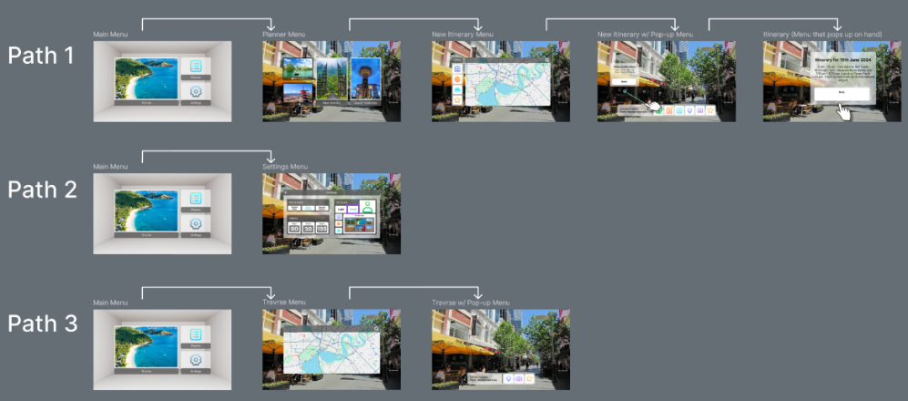

*1.1 An example of three different “paths” the user can take in prototype A. Found in the “Travrse HiFi Protoype” Figma file.*

Our First prototype design follows a hierarchical or “tree-based” menu structure, where a person will pass through several separate menu screens, with the end screens providing the main functionality. They can take different paths through the menus which leads to the user performing a different action within the app.

This helps to avoid having too many menu options on one screen at a time, making the UI easier to understand and more accessible to more users. If the user does not know where they want to go in the menu, each menu option is clearly labelled and easy to identify. When they want to go back up the tree of menu, a menu option will be present to do so. The user does not need to see parts of the menu that they may rarely use.

### Prototype B

 Our second prototype uses a “tabbed” menu layout, where each separate functionality is indicated as a separate tab on a single menu. Though there may be more menu options present on the screen at a time, the user gains the ability to access features of the app more quickly with less inputs required.

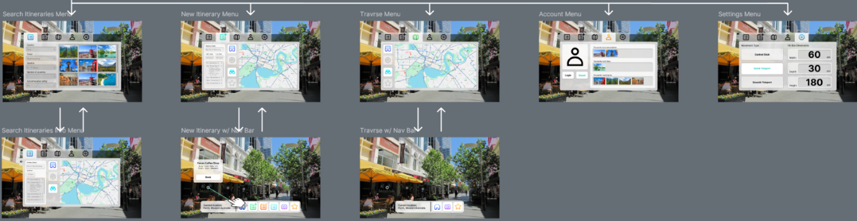Such a consideration is important in a Virtual Reality environment where a user may not want to spend a long time with their hand raised to point at the menu and follow a path of menu options, along with the extra time holding their controller pointer over a menu option to view a tooltip for a button they don’t know/remember. In a tabbed design, the user needs to view the tooltip for each menu only once and is more likely to remember it as the tab options are always visible to the user.

*1.2 An example of a "tabbed" menu design in prototype B, found in the “Travrse HiFi Prototype” Figma file.*

A user is also able to access settings in only two clicks while browsing the virtual space, rather than having to completely leave what they were doing in order to access the settings, as is the case with prototype A.

Our usability testing report will analyse the strengths and weaknesses of both designs, which will provide us with feedback that we can use to create a final prototype.

## Participants

Participants were selected primarily for the purpose of generating a dataset that can be used to identify pain points in our prototypes, and to help us to make informed changes to our UI design that improve the user experience of our application.

As a reminder, our key demographics are:

* Young adult/Tertiary student
* Working middle to upper-class middle-aged adults
* Elderly travellers
* Parents

Anyone in those demographics at all ranges of tech literacy are the target audience of Travrse.  Due to time restrictions and a lack of resources, it is difficult to gather enough test participants that fit all of our target demographics. For the purposes of this project, young adults and middle-aged working adults were the audience that we focused on in our participant pool. It is also difficult to accurately gather test participants with a wide range of perceived tech literacy, as tech literacy is (on average) higher among younger demographics, and a user may incorrectly rate their own tech literacy as higher or lower than what it really is. For that reason, data collected in our interviews may be skewed to favour the suggestions of those who have higher levels of tech literacy. While it would have been extremely useful to gather data from elderly test participants, research data from academic literature can also be used to help guide our design choices to ensure our changes continue to appeal to all of our target demographics.



Piloting &

Analytics

07

09

# Piloting

## Study Objective

To determine how easy the application is to navigate and use at varying levels of technology literacy. Our aim is to use this pilot test to determine what questions will help us best gauge participants experience with various features of the software, which in turn will help us identify problem areas in need of improvement.

## Informing Researchers and Deployment

All researchers played a part in the formulation of the research questions and thus were informed throughout the whole process. We conducted the pilot by working through the survey ourselves with the mindset of potential users and how to best measure their responses for useful data from the questions, such as whether to use qualitative or quantitative metrics.

## Pilot Result Evaluation

After conducting the pilot test, we changed the wording of certain questions to remove ambiguity as we had found them to be potentially confusing for participants completely new to the software. We also formulated additional questions to gauge participants perception of Travrse and similar travel applications. With these changes we determined that handling this survey with participants of more general demographics would be feasible and provide valuable insight.

# Experimental Data collection

## Collection Focus

We decided to focus on qualitative measures of difficulty with features as due to this being an early prototype, quantitative metrics such as number of clicks and time taken can vary wildly depending on potential changes to the software later on, the most pertinent of these changes being the navigation of the software being with a VR headset rather than desktop application. This lead to our questions mostly being of a qualitative but unbiased nature, with them being asked for opinions of travel applications or to provide input on how difficult they found completing certain tasks within the prototype.

## Collection method

Our data was collected by entering the participant responses in a form ourselves while they completed the test, with us later collating the responses for analysis. The test was conducted by sitting down with the participant with a computer that can access the internet and asking them for some information before we had them complete any tasks. During the test we had them complete tasks connected to various features such as creating an itinerary or navigating to the settings to personalise their experience, with the participants later being asked to rank them in order of difficulty.

## Key Data Points

* What people at different levels of tech literacy find difficult to accomplish within the app.
* What activities are consistently difficult for users to execute.
* Identify imbalances in the usability and quality of the user experience between demographics.

# Analysis of usability testing report and extra research

## Participant Profiles

<https://library.xtensio.com/usability-testing-report-template-and-examples>

|  |  |  |  |  |  |  |
| --- | --- | --- | --- | --- | --- | --- |
|  | Prototype | Age | Tech Literacy | Preferred Device | Relationship Status | Num of Children |
| Participant 1 | A | 22 | 6 | Mobile Phone, Laptop, Tablet | Engaged | 0 |
| Participant 2 | B | 20 | 5 | Mobile Phone | Single | 0 |
| Participant 3 | A | 17 | 6 | Mobile Phone | Single | 0 |
| Participant 4 | A | 20 | 6 | Mobile Phone | Dating | 0 |
| Participant 5 | B | 22 | 7 | Mobile Phone | Single | 0 |
| Participant 6 | B | 39 | 7 | Mobile Phone | Married | 7 |

### Profiles Summary

* All participants indicated that they are most comfortable using a mobile device, prompting that using the same design principles of mobile applications could smooth the transition to a VR environment.
* Majority of participants were sourced from a university demographic
* Tech literacy across all participants averaged at a 6, with a minimum of 5 and a maximum of 7, with a more diverse and extreme set of literacy levels potentially generating different results.

## Task responses

|  |  |  |  |  |  |
| --- | --- | --- | --- | --- | --- |
| Ranking of tasks (1-5 Easiest to Hardest) | | | | | |
|  | Create an Itinerary | Add an Item to Itinerary | Remove an item from the itinerary | Open an existing itinerary | Navigate to the settings menu |
| Participant 1 | 1 | 3 | 4 | 2 | 5 |
| Participant 2 | 2 | 3 | 4 | 1 | 5 |
| Participant 3 | 1 | 2 | 5 | 3 | 4 |
| Participant 4 | 1 | 3 | 4 | 2 | 5 |
| Participant 5 | 2 | 3 | 5 | 4 | 1 |
| Participant 6 | 5 | 2 | 4 | 3 | 1 |

### Results Summary

* Participants found creating an itinerary to be the easiest task on average while many found finding the settings the most difficult, however many participants cite this being due to navigating to the settings menu being the last task rather than any difficulty.
* One participant cited difficulty in completing many of the tasks being due to the similar screens across different tasks, indicating stronger variance would improve their enjoyment and understanding of Travrse.
* One task that took extra direction to complete across multiple participants was the removal of items from the itinerary, indicating the need to simplify the process.

## Supplementary research

To supplement our limited participant survey data, the following extra points were also considered when making changes to our UI:

## Using our application in Virtual Reality

Of course, Travrse is designed and intended to be used in Virtual Reality. Unfortunately, due to limitations in the availability of testing software and hardware, as well as time constraints, it was not possible to develop a test in Virtual reality. One corporate article notes that Standalone headsets are best for first time users, and notes that Virtual Reality sessions should be kept to an average of 15-minute sessions to avoid motion sickness. [(SOURCE 1)](https://virtualspeech.com/blog/guide-training-employees-vr) Users more experienced with virtual reality may be able to use our application for longer. [(SOURCE 2)](https://www.sciencedirect.com/science/article/abs/pii/S0003687022000217)

Our application must be designed to maximize immersion and provide a simple User Interface to avoid motion sickness as much as possible, as it is highly likely that most first time users will have some degree of sickness. [(SOURCE 3)](https://link.springer.com/article/10.1007/s10055-021-00513-6)

Furthermore, Virtual Reality as a method of virtual touring has been shown to be an effective method of enhancing immersion, and the method is even described as superior to static images. It was also noted that Virtual Reality is becoming more commonplace and the majority of people have heard of the technology, while an increasing number of people now say they have had experience with the technology in the past. [(SOURCE 4)](https://catalogue.curtin.edu.au/discovery/openurl?institution=61CUR_INST&vid=61CUR_INST:CUR_ALMA&volume=61&date=2021&aulast=Spielmann&issue=2&issn=0021-8499&tabs=viewOnlineTab&spage=147&id=doi:10.2501%2FJAR-2020-015&auinit=N&title=Journal%20of%20advertising%20research.&atitle=Can%20advertisers%20overcome%20consumer%20qualms%20with%20virtual%20reality%3F:%20Increasing%20operational%20transparency%20through%20self-guided%20360-degree%20tours&sid=google) From this, we can assume that most of our users understand the concept of virtual reality and may have even tried it in the past, and if our test was conducted in VR, the responses would likely be mixed with both positive responses and non-favourable responses. Those with non-favourable responses would likely mention nausea and difficulty handling the new interfacing method (using controllers) as the largest pain points.

## Virtual reality in Elderly users.

Given that our test participants did not consist of elderly users, we can use other research to note significant points to consider for elderly users who use our application in Virtual Reality. It has been suggested that that the user experience in Virtual Reality does not solely depend hardware. While having hardware that supports high fresh refresh rates and wide field of vision helps, the application design is also just as important. Elements such as high contrast between UI elements and using raw colours in the design, as well as larger elements are important to ensure that the UI is easy to interact with and understand.

It is also of significance that elderly users in other experiments and tests have directly expressed their enjoyment of the experience and found it stimulating, with some participants noting that they “expressed the desire to once again attend cultural events or locations that they had already visited in their lives.” [(SOURCE 5)](https://doi.org/10.20870/IJVR.2019.19.1.2908)

This prior research strongly suggests that that if our test involved elderly participants, their response would be similar to what has been noted above, and pain points would consist primarily of difficulty understanding UI elements and navigating the interface, with nausea being a secondary pain point. Pain points regarding the experience being in virtual reality as compared to non-VR would be minimal.



Feedback

Adjustments

10

# Final High fidelity prototype design

From the user tests that we had performed, there was a common theme surrounding what the most difficult tasks to perform were. This resulted mainly from confusion and indicated that we had to work on the affordance and intuitive aspects of our UI design. All of these tasks however surrounded the operation of the itinerary, the main operations users had were:

* Adding to itinerary
* Removing from itinerary
* Viewing the itinerary
* Creating a new itinerary

To address this issue, we will compare and contrast the changes made between the old and the final prototype.

## Adding to/Removing from Itinerary (Initial Version)

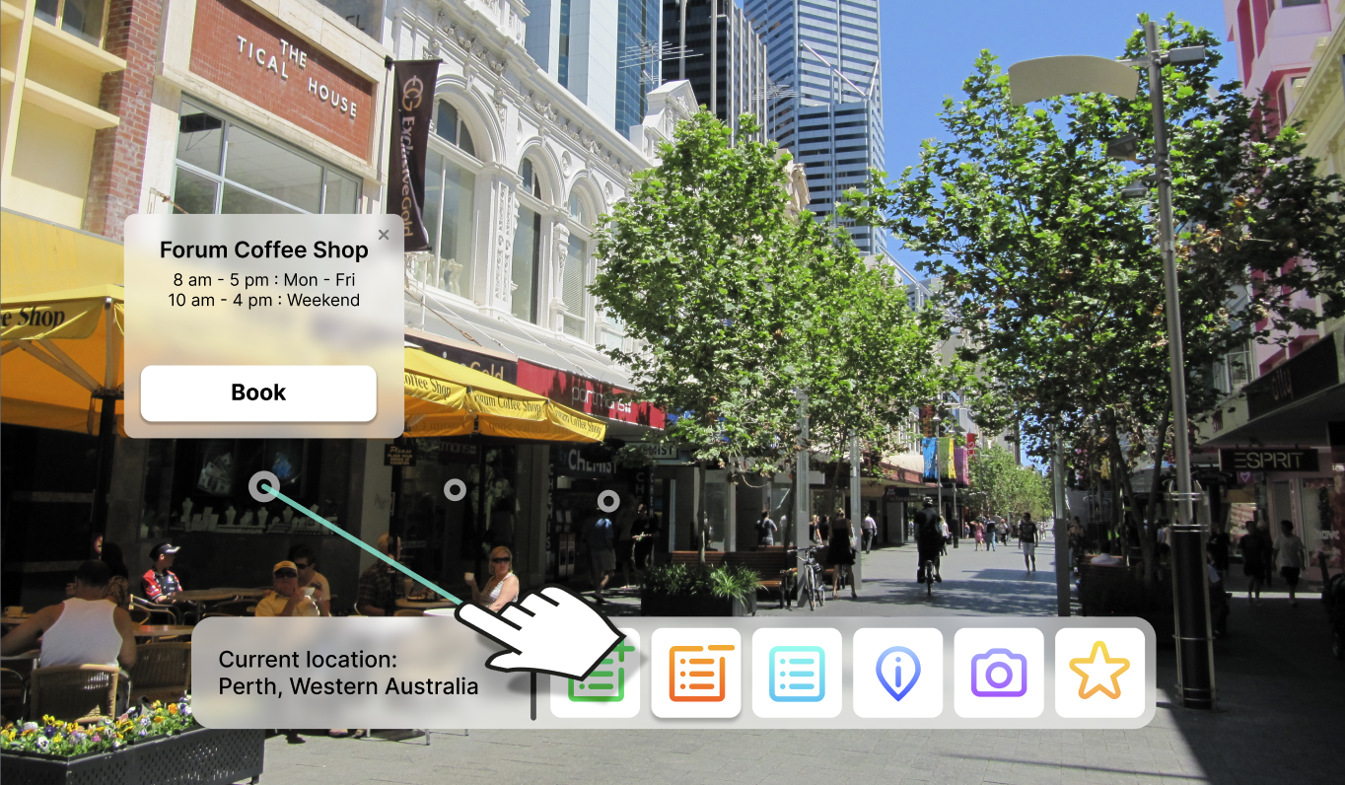Previously when adding an item/event to the itinerary, users would need to enter the ‘street view’ and view a location or landmark. Once they view this landmark, they would need to select it and select book. The downside of this approach was that the user interface would not update the location in street view to let users know if the location had been booked or not. Versions of the previous user interface can be found below.

*Figure 5.1: Selecting an location/landmark from street view*

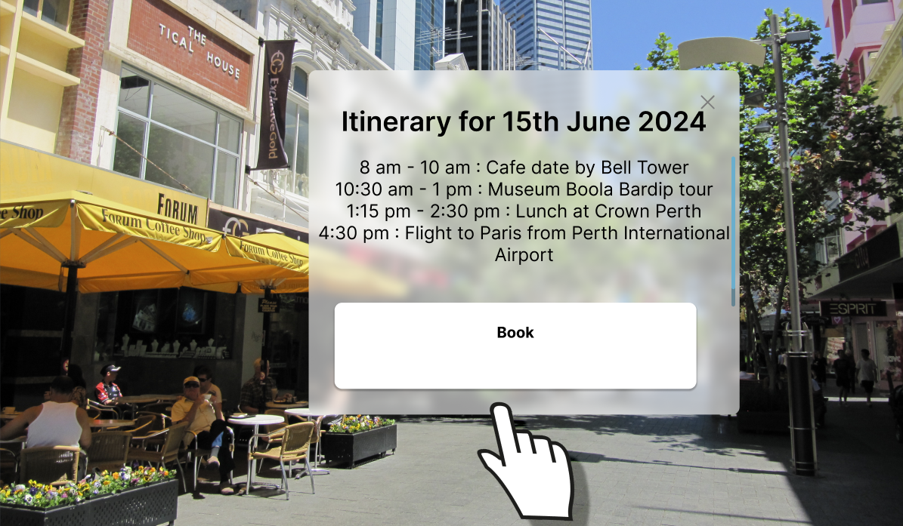*Figure 5.2: Booking the location (adds to itinerary)*

*Figure 5.3: After adding to itinerary (no indicator it has been added)*

One of the confusing points that users had was between figure 1 and figure 3, as there was no indication of the user’s location having been added to the itinerary. After it had been added as well, users were not sure how to remove items from their itinerary.

In this version, the appropriate steps to remove an item from their itinerary would have been to select the orange itinerary button with a ‘-’ icon at the top right-hand corner of the icon.



*Figure 5.4: Button to remove item from itinerary*

From post-testing questions, we got feedback that the icons themselves made sense (good level of affordance), the process to remove items from the itinerary itself were just not intuitive. Thus, for changes, we put more focus looking into what the process was to remove an item, rather than the icons used.

## Adding to/Removing from Itinerary (Final Version)

In the iterated final version, we had changed how to remove items from the itinerary. Since the icons themselves weren’t the problem, we played around with placing the ‘remove from itinerary’ button in different places/screens.



*Remove from itinerary button*

In the previous version, buttons for adding to and remove from the itinerary were all left in the control bar at the bottom of the screen. However, this resulted in a large number of buttons in the control bar, and one issue was that users did not know what they were adding to or removing from the itinerary as these options would not be present when a user selected a location to view more information.

In the new version, we have decided to remove the add and remove buttons from the control bar and instead have them in the actual info screens of the locations that users are interested in or viewing. We found that doing so helped us to:

* Reduce clutter in the control bar and stops overwhelming users with controls (this will also increase how easy the interface and controls are to learn)
* Narrows the scope of the buttons so it makes more sense when to add or remove items from the itinerary (and what you are adding or removing.

*Control bar (initial version)*

*Control bar (final version)*

With a reduced number of buttons present in the control bar, this also allowed us to make the buttons bigger, making it less likely that a user will incorrectly select a button, improving learnability and efficiency.

In the final versions, users would now select a location, and this pop up would display on the screen, showing more information in a more structured and organised way as opposed to the previous version (refer to figure 5.2 for the previous version).

The information displayed includes:

* Picture of the location/landmark
* Name of the location/landmark
* Address of the location/landmark
* Business hours in a more familiar and structured way
* Current booking to display if the user already has it in their itinerary
* 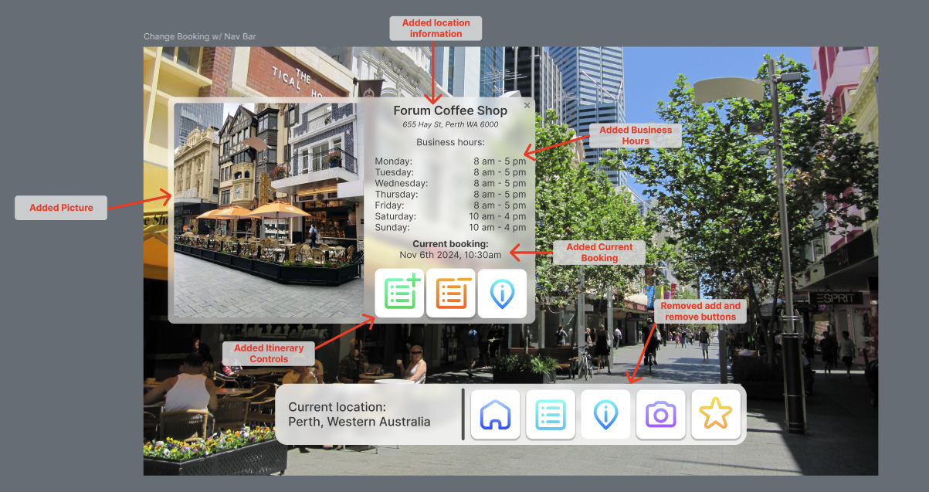Button controls

The choice to add **pictures, name, address, and business hours** is to provide users with more information about the place to make it easier to add to their itinerary. Previously none of this information was displayed and would have made it harder for users to add it to their itinerary without knowing when that place was open, where it was located, and not all users may remember what it is called after selecting the pop-up.

## Layout, Size, and Colour

To highlight what information is important, we have made use of visual hierarchy and size. Having the image be the largest element, this is to give users a visual aid to help remember what they are viewing/about to add or remove from their itinerary. As users read left-right, from top-to-bottom, we have included this image on the left side of the pop-up.

On the right side includes the information, with the largest text being the name of the location/landmark. This information including, the name, address, and business/operating hours of the location.

The next bolded text highlights more importance and separates the user interface into a separate piece of information which is whether or not the user has currently added this to their itinerary. Having this bolded is important to show that these pieces of information are not directly related to each other, but relevant to the panel.

Next at the bottom, with vibrant colours to signify importance, we have the button controls for users to add, remove, or find more information about the location.

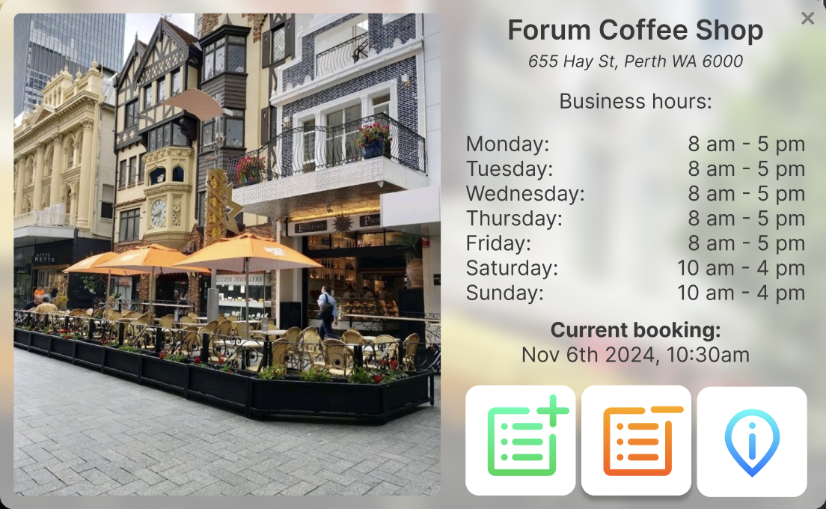*Use of layout, size, and colour to create a visual hierarchy*

## Trading hours

When selecting how to present our trading hours, we did some research on current methods used to display business hours to make it as similar to what users currently experience in real life.

|  |  |
| --- | --- |
| *Googles trading hours format* | *Canva trading hours format* |

*Figure 5.5 Trading hours templates*

Taking inspiration from how business/operation hours are currently displayed, we used this in our own design to increase usability as users navigate and digest information in Travrse.

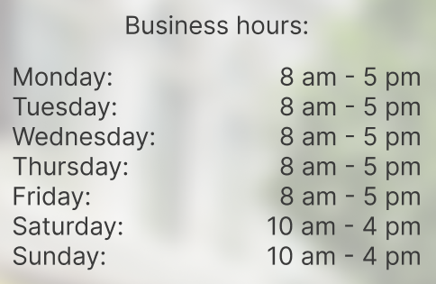

*Figure 5.6: Trading hours format*

We have also moved the button to this pop-up rather than having them in the control bar. This makes it more intuitive as to what the user is adding to or removing from the itinerary as it exists within the pop-up of the place that they are viewing. In this new version, the buttons that show are conditional, dependent on whether or not the user already has this location/landmark added to their itinerary. If it is not in their itinerary, the option to remove will be greyed out and inactive (see figure 5.5). The only buttons that will be active for the user to use will be the ‘add to itinerary’ button, and the ‘information’ button.

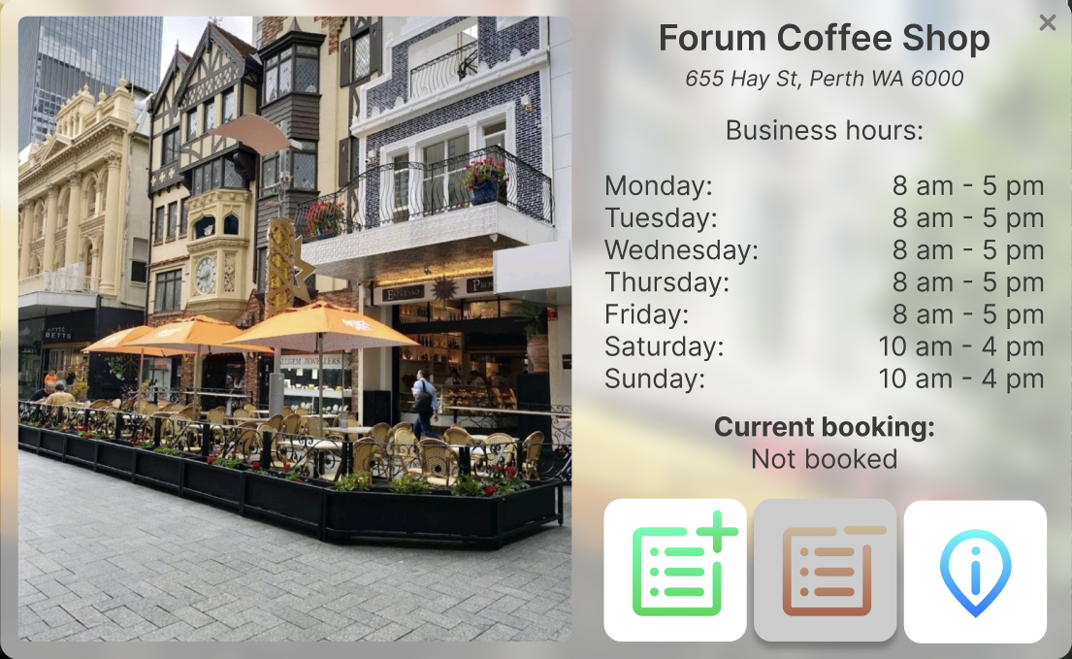*Figure 5.7: Not booked info page (final version)*

However, if the location that the user is viewing is already in the itinerary, then the remove from itinerary button will then become active for users to use (see figure 5.6). if this exists in the itinerary already, all three button options will remain as it is possible that a user may wish to visit the same location more than once on their trip.

Users will also have an indication as to whether or not they have this currently in their itinerary which will be displayed under the ‘**Current booking**’ section.

*Figure 5.8: Booked info page (final version)*

Another pain point that users experienced when using the initial version of the prototype was that they could not tell if something had been added to the itinerary. Whilst we have added the ‘**Current booking**’ part in the pop-up to show users if a location they are viewing is currently added to the itinerary. When users would return to the street view, there would be no indicator and all the icons would still be grey.

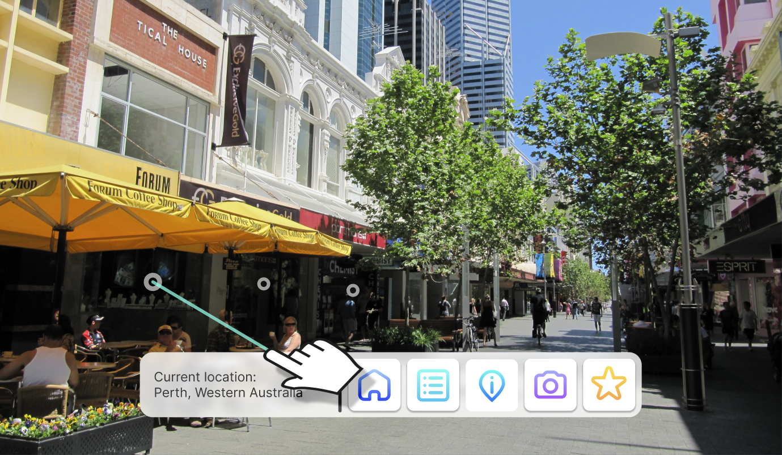*Figure 5.9: Street view with no booking*

## Point of Interest Markers

A new design choice that we had made was to have the icons turn green if the user has made a booking for that location. This will give the users some feedback when something is added to the itinerary.

In the final version of the prototype, users can only add location to their itinerary from the pop-up menu for that specific location and when a user adds a location to their itinerary, the ‘**Current booking**’ value would change, along with the ‘**Remove from itinerary**’ button changing state from inactive to active.

We have considered implementing a toast to notify a user when something has been added to the itinerary, however with these new changes, it would be unnecessary to implement a toast and would likely be too overwhelming for the user, especially since they would be hearing a VR/AR headset.

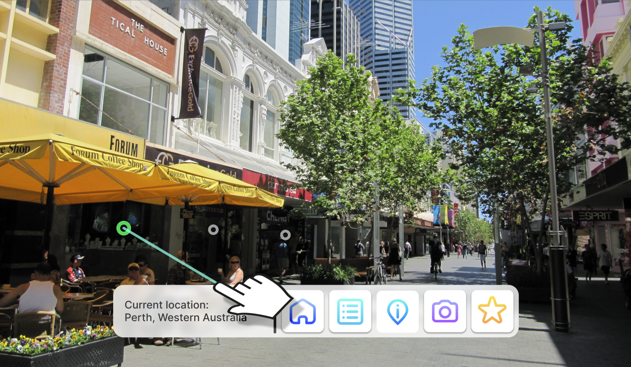*Figure 5.10: Street view with booking*

## Itinerary Planner View

Another piece of feedback from users that we got was that some users felt it was confusing to have to enter a location to remove an item from their itinerary. Taking this into consideration, we have decided to make it possible for users to remove itinerary events from the itinerary menu.

Users can remove these items by hovering over the event on the daily calendar view in the itinerary menu and by clicking the red *rubbish bin* icon (see figure 5.11). Users can go through the days they are staying, and remove items from other days as well by selecting the day and selecting the arrows to move to another week.

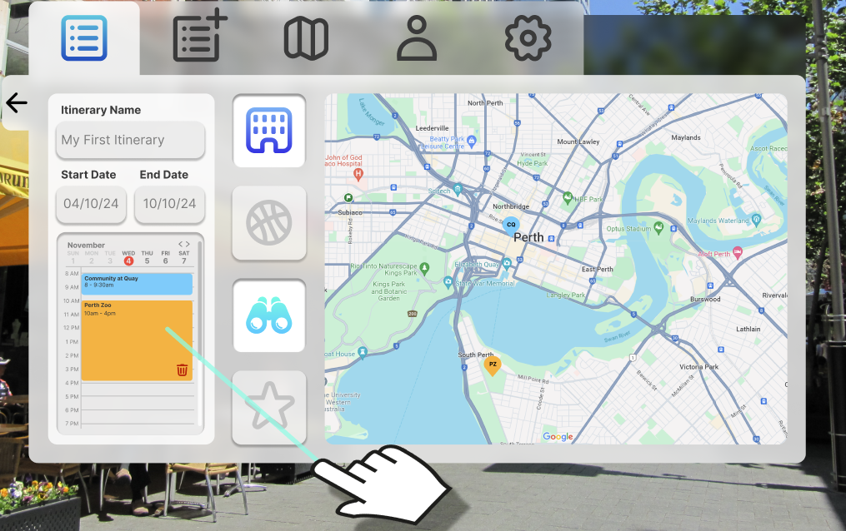*Figure 5.11: Remove itinerary event from menu*

## Viewing the itinerary

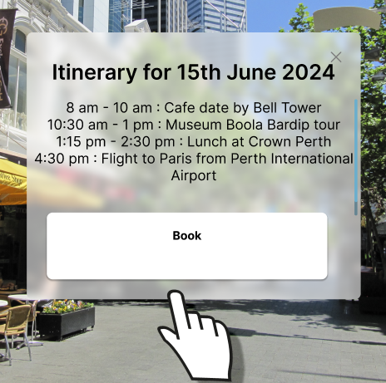One other pain-point that users experienced with the initial version was with viewing the itinerary. Users did not know if they were viewing their itinerary or not, or how to get to it.

The only screen that users had to view the itinerary in the old version was when they were making a booking or adding an event to their itinerary.

Taking this into account, we have created a dedicated itinerary screen to give a more comprehensive break down of the user’s itinerary. In this screen (rather than a pop-up) we have included:

*Figure 5.12: Old itinerary screen*

* A map to show where the locations they are visiting are on any given day.
* A daily calendar view to see how their day is structured
* Buttons to toggle the types of activities they are visiting on the map.
* Show accommodation
* Show recreational activities
* Show favourited locations
* Show landmarks

We believe that by having this breakdown, users will not only have the ability to view their itinerary in full detail, but this will make the overall planning experience easier for the user, improving the apps **utility**.

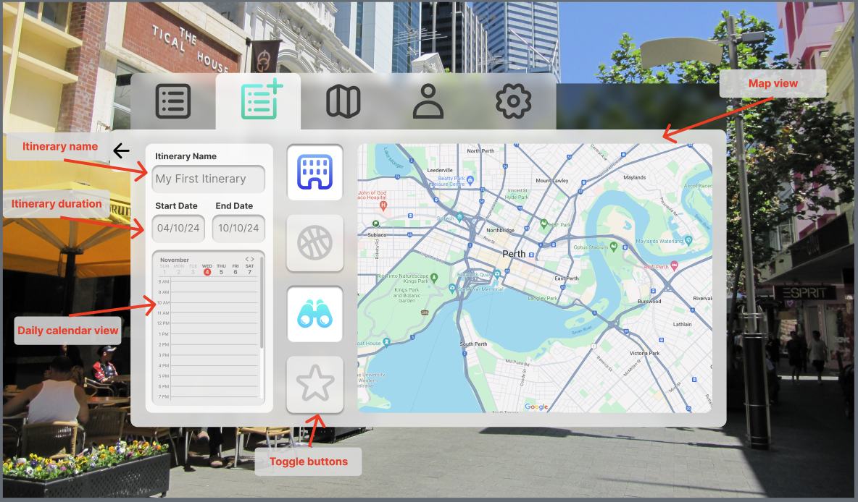*Figure 5.13: New itinerary screen with added features*

## Layout and size

Given that we wanted to include a decent amount of information on this one small screen, we had to think critically about the layout of the elements and the composition. The most important information is usually placed in the order of what the user would read first. As this page is laid out horizontally, the most important information would be at the most left-handed side of the screen.

The information that we felt was the most important is the itinerary itself and it’s information, this includes the name, the duration, and the breakdown of what is happening in the itinerary.

Then came the map and its filter buttons as these are a utility of the itinerary, allowing users to visually see where they are travelling on any given day, helping to estimate travel times and perhaps group events together to reduce travel time.

Usually, the most important elements are the largest on the screen, however since maps are a visual element and a larger display would result in better ease of use, we have opted to have the map take up a larger space as opposed to the itinerary and its information. We have still highlighted the importance of the itinerary by positioning the itinerary information on the left-hand side of the screen.

## Colour changes

Changes to our choice of colour across text and icons have been made to reduce the contrast between colours. The aim of this design choice is to reduce the strain on the eyes when looking at icons, making this easier on the eyes and allowing users to use our application for longer without straining their eyes. See the initial design (Figure 5.14) and the final design (Figure 5.15) for differences.

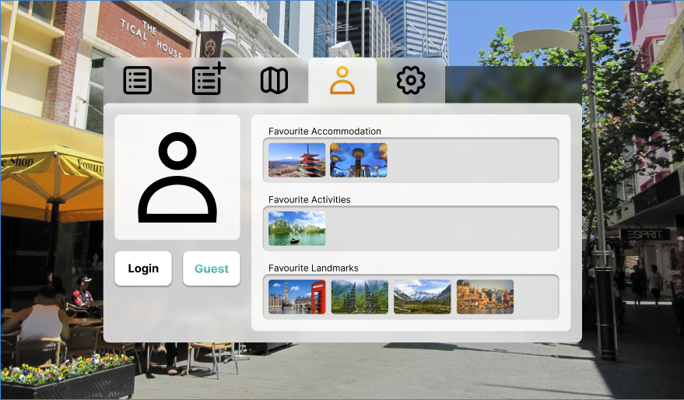*Figure 5.14: Using full black (#000000)*

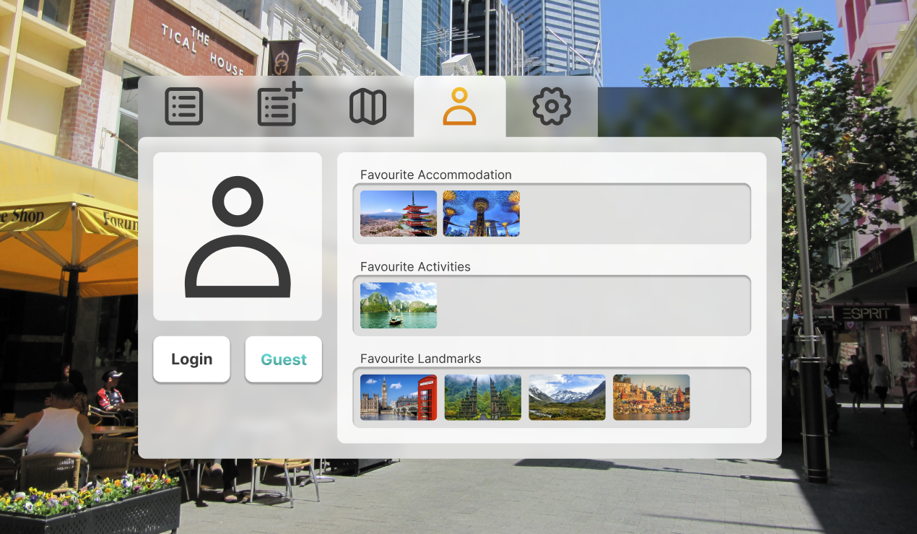*Figure 5.15: Using dark grey instead*



11

Final

Prototype

# Final High-Fidelity Prototype

After conducting usability tests, we found that the alternate prototype’s design was far better than the original. Because of this, we decided to base the final prototype’s design on the alternative prototype. We also received a lot of extra feedback on what features the users struggled with the most. This feedback was used to refine the design of the alternative prototype, leading us to the final prototype design that we have now.

## Introductory Screen

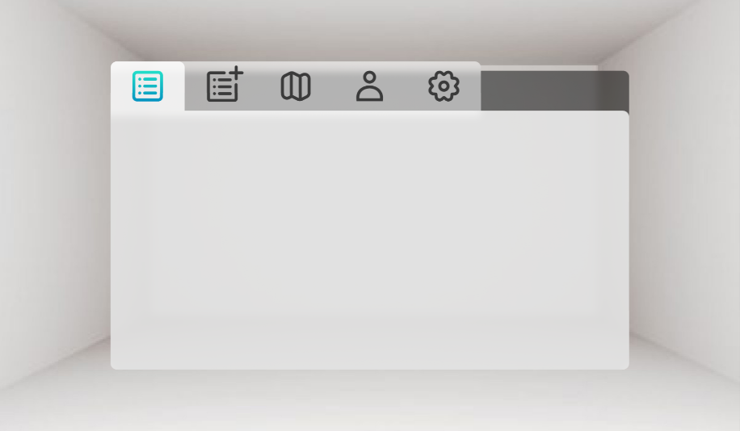This screen remains mostly the same with the only difference being that the tab icons now a dark grey instead of black. This colour tweak can also be seen throughout the rest of the screens. The introductory screen still serves the same purpose as before, acting as a loading screen that helps users to slowly get used to the VR experience.

## Search Itinerary Menu

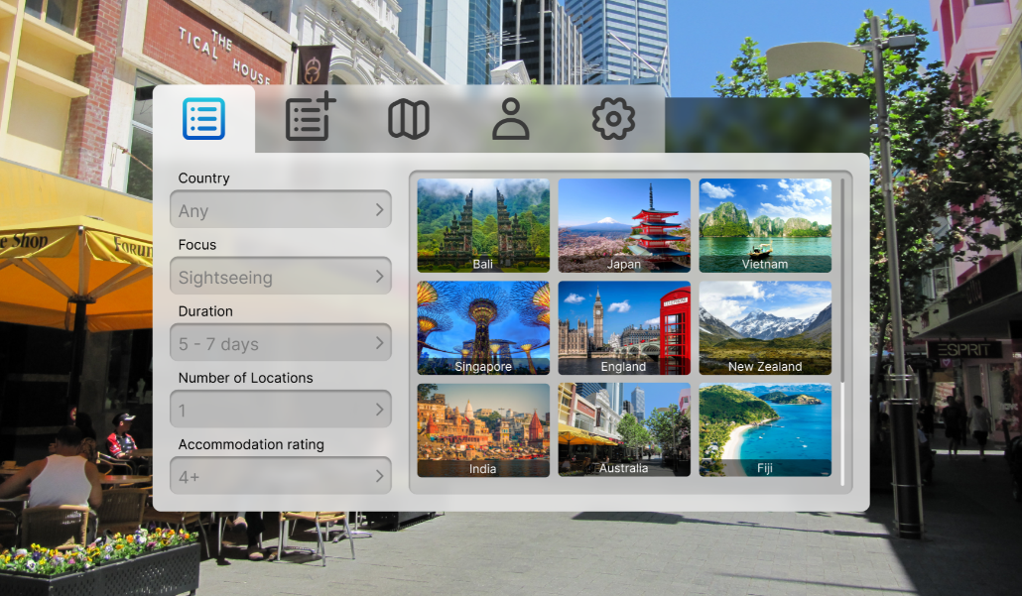The search itinerary menu has remained the same as it was in the alternative prototype. None of the users that tested the alternative prototype experienced any difficulties when using this menu, so we decided to keep the original design.

## New Itinerary Destination Menu

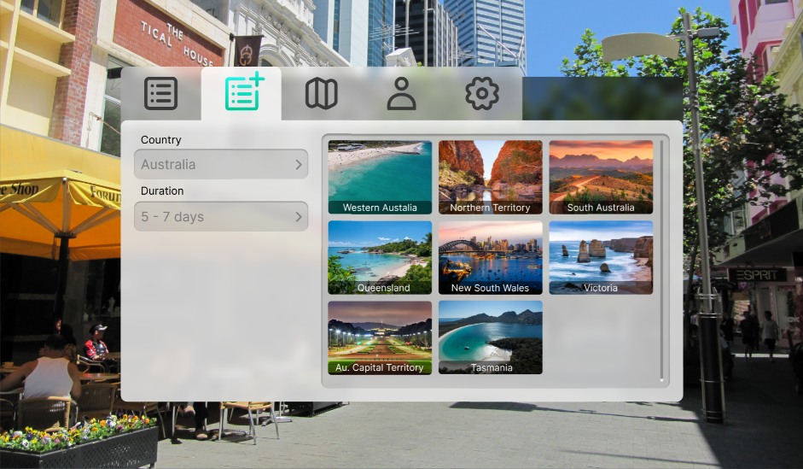Instead of the create itinerary tab going directly to the planner and map menu, we added a new intermediate menu. The new itinerary destination menu allows users to filter destinations based on what countries they would like to visit, as well as allowing them to add the desired duration of their holiday. This makes starting a new itinerary much easier than in previous iterations when users had to use the map to select their starting destinations.

## Travrse Menu

The Travrse menu has remained unchanged from the alternative prototype. This menu was intentionally kept very simple as it allows users to get into exploring the world as soon as possible.

## Account Menu

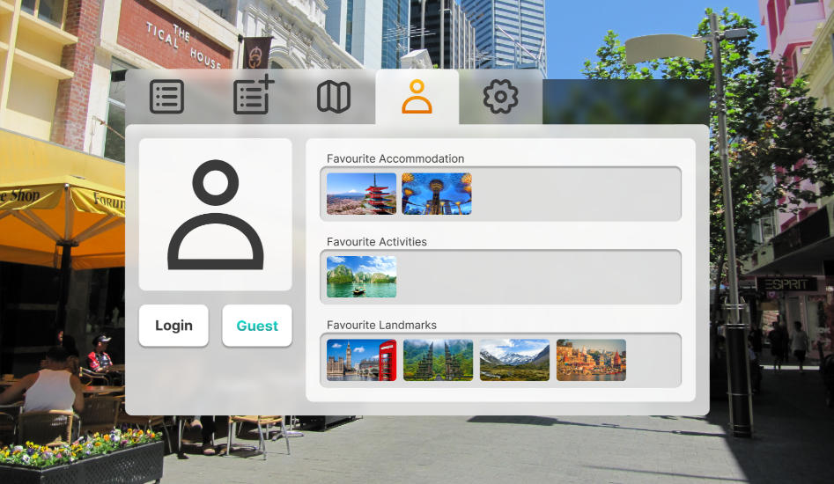The account menu also remains unchanged from the alternative prototype. The user’s favourites are split into their respective categories to make them easier to find. Clicking on the images displayed will teleport the user to that location. Guests can still save favourites, but they will be erased after the session.

## Settings Menu

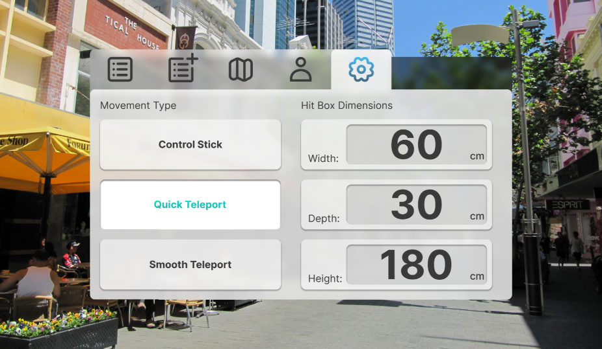The settings menu remains unchanged since the alternate prototype. We wanted to keep the settings menu as simple as possible in order to not confuse the user. We simply offer three different forms of movement for user comfort, as well as adjustable hitbox dimensions to help users with diverse needs.

## Search Itinerary Information Menu

The search itinerary information menu received a big update from the alternate prototype, that being the planner/calendar on the left. The old text-based calendar felt a bit too clunky in the end, so we instead opted for a visual calendar design. This is a much more intuitive way of interacting with the planner.

## New Itinerary Menu

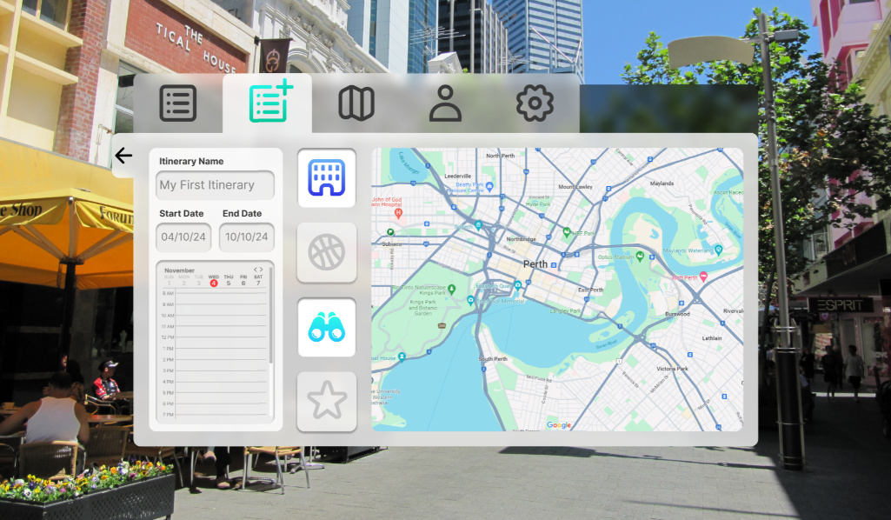The new itinerary menu shares a lot of the same elements as the previous menu, but with editable features. The name of the itinerary can be changed, the start and end dates can be chosen, and the planner updates as the users adds new items to their itinerary.

## Search Itinerary Explore

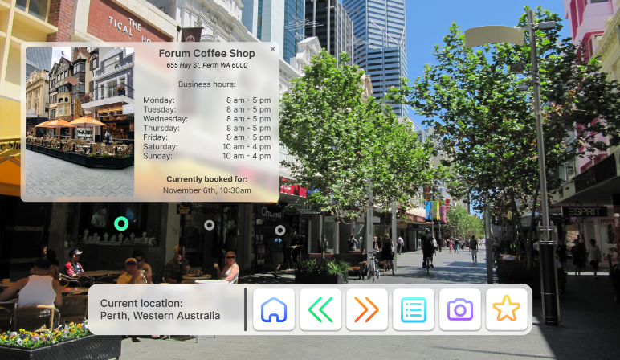The search itinerary explore screen has received some slight changes. The navigation bar has received an update in the form of a home button. This button simply opens up the main menu, making it easy for the user to navigate back to whatever it is that they were last doing. The pop-up menu that displays when users click on a point of interest has also changed. The menu now displays information such as the name, the address, and the opening hours. Below all of that information the menu also displays the current booking within the itinerary, if there is one. The markers for points of interest that have been added to the itinerary are green in colour rather than the standard grey as seen in the screenshots.

## Travrse Explore

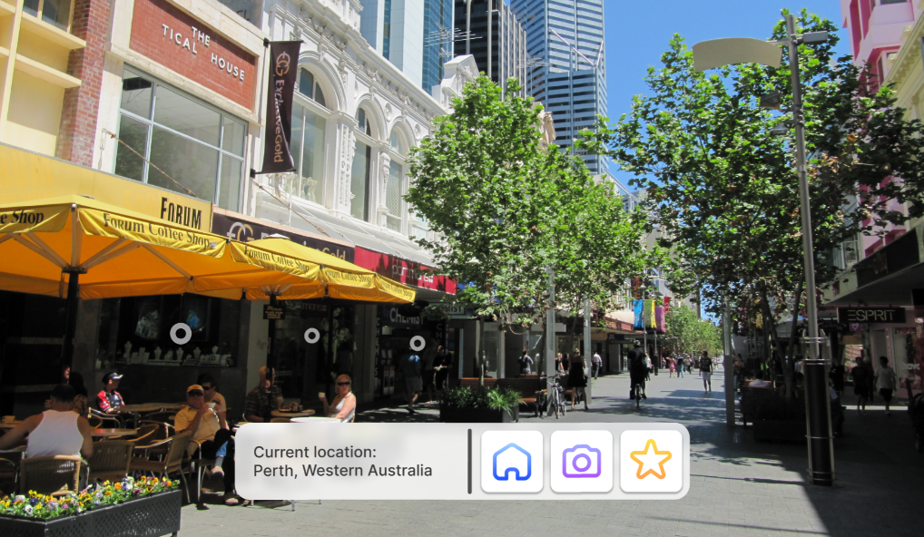The travrse explore screen is very similar to the other explore screens, but with a much simpler navigation bar. It remains mostly the same as in the alternate prototype, with the addition of the home button, also seen in all of the other explore screens.

## New Itinerary Explore

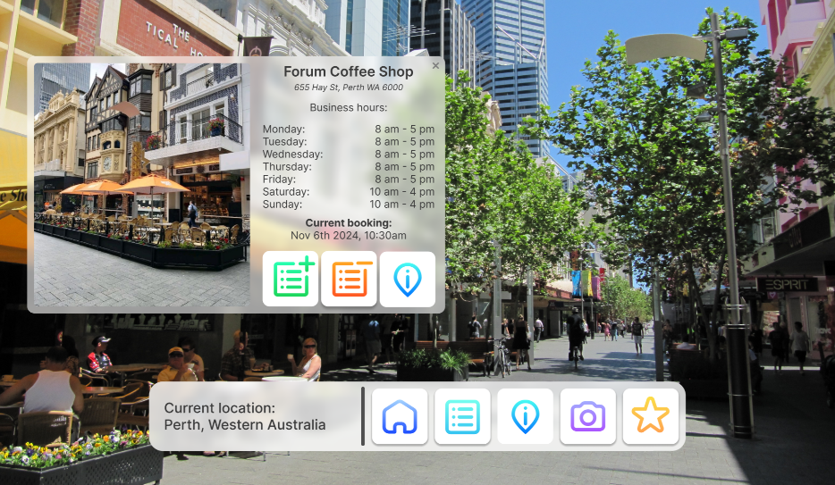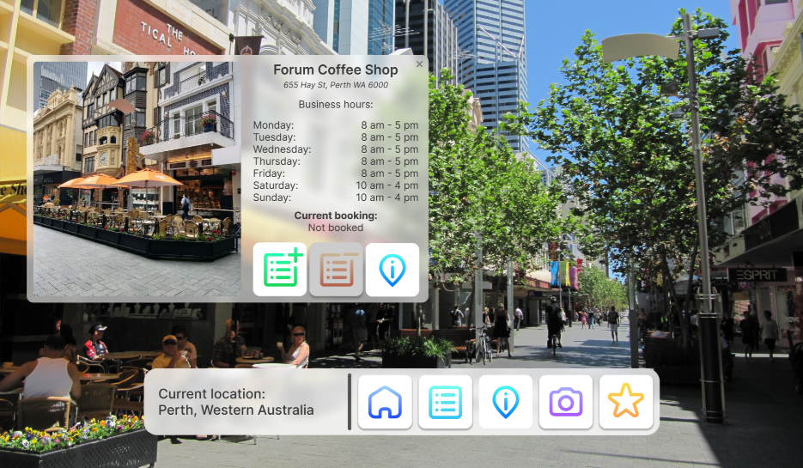The new itinerary explore screen has received a lot of the same changes mentioned in the previous explore screen, with the addition of some extras too. The navigation received the addition of the home button like the other explore screens, but we also removed the add to itinerary and remove from itinerary buttons. These two buttons were instead moved to the pop-up menu that appears when a point of interest is clicked by the user. This helps to avoid confusion with users not understanding which points of interest are being added and removed. A second information button was also added to the pop-up menu. The information button in the navigation bar still displays information of the user’s current location, and the pop-up menu information button displays more information on the point of interest that the user is currently looking at. When the user already has a booking at the specific point of interest that they are inspecting, they are able to add more bookings or remove the current ones. When no bookings have been made however, the remove button is simply greyed out. Greying the button out immediately signals to users that that option is not available, but still shows that it can be done when they do have bookings.



Handoff

Report

12

# Handoff report

## Logo

### Logo With Text

Icon Size: 230pt x 200pt

Text: Nunito size 96, 432pt x 131pt

**Colours**

Text: #000000

Globe: Linear Gradient #80F0FF - #6A70FF

VR Headset: Linear Gradient #828282 - #000000

### Logo Without Text

Icon Size: 340pt x 320pt



**Colours**

Text: #000000

Globe: Linear Gradient #80F0FF - #6A70FF

VR Headset: Linear Gradient #828282 - #000000

## Icons

### Menu Icons



**Itinerary Menu**

Size: 50px x 50px

Colour: Linear Gradient #23E0C9 - #0393C1



**New Itinerary Menu**

Size: 50px x 50px

Colour: Linear Gradient #21F4E7 - #02C898



**Travrse menu**

Size 50px x 50px

Colour Linear Gradient #74E56A - #009A2B



**Account Menu**

Size: 50px x 50px

Colour: Linear Gradient #FFBE18 - #E36D00



**Settings Menu**

Size: 50px x 50px

Colour: Linear Gradient #47BDF0 - #466982

### Category Icons



**Accommodation Category**

Size: 50px X 50px

Colour: Linear Gradient #6AB3F7 - #2F36E5



**Activity Category**

Size: 50px x 50px

Colour: Linear Gradient #FFA825 - #FF5825



**Landmark Category**

Size: 50px X 50px

Colour: Linear Gradient #2DFFE6 - #23CAFF



**Favourites Category**

Size: 50px X 50px

Colour: Linear Gradient #FBDF47 - #FF7E21

### Taskbar Icons



**Return to Home Screen**

Size: 50px X 50px

Colour: Linear Gradient #A5D4FF - #1D4FFF



**View Itinerary**

Size: 50px X 50px

Colour: Linear Gradient #76FFEF - #35C4F2



**View Location Info**

Size: 50px X 50px

Colour: Linear Gradient #48FDF3 - #0176FF



**View Location Info**

Size: 50px X 50px

Colour: Linear Gradient #A2ABFF - #AA56FF



**View Favourites**

Size: 50px X 50px

Colour: Linear Gradient #FBDF47 - #FF7E21

### Point of Interest Menu Icons



**Add Item**

Size: 40px X 40px

Colour: Linear Gradient #27FFB1 - #1CD75C



**Add Item**

Size: 40px X 40px

Colour: Linear Gradient #FFA824 - #FF5824



**View Location Info**

Size: 40px X 40px

Colour: Linear Gradient #48FDF3 - #0176FF

### Disabled Icon Specifications



**Menu Tab Icons**

Colour: #3A3A3A



**Category Icons**

Colour: #C4C4C4

## Screens

This section utilises screenshots from a Zeplin auto handoff project with the design being shown at <https://zpl.io/q1mBQlN>

### Menu Template

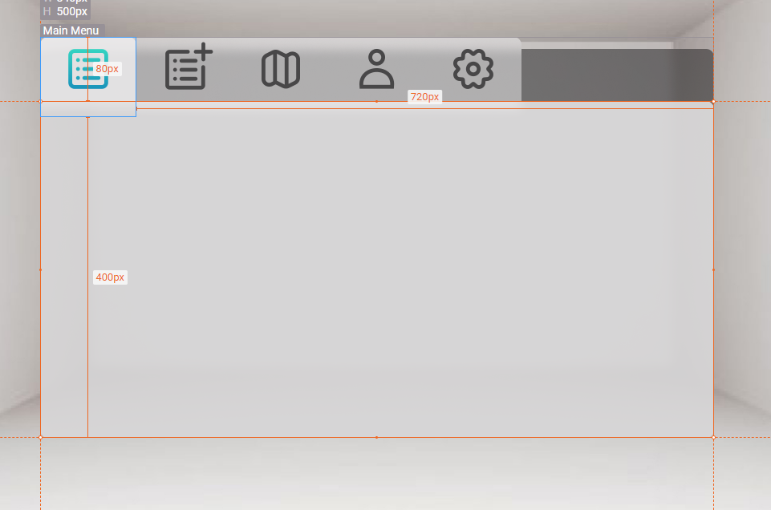**Sizes**

Menu Size: 840px x 500px

Tabs Size: 80px x 120px with 5 in a row

**Colours**

Tab Section: #FFFFFF at 50% opacity

Selected Menu Section: #FFFFFF at 80% opacity

**Font**

Body Text – Inter Regular

Headings – Inter Semi-Bold

Subtitles – Inter Italic

Settings Numbers – Inter Bold

### Existing Itinerary

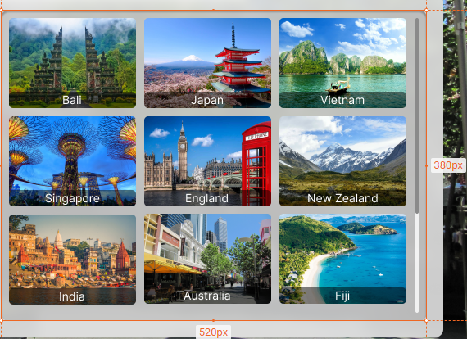

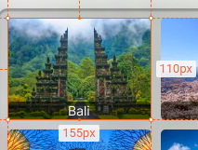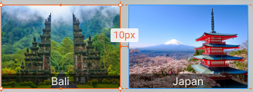

### Search Itinerary

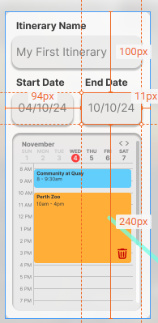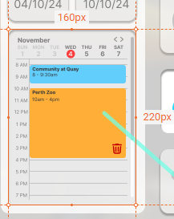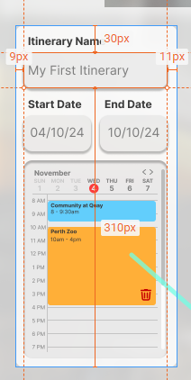

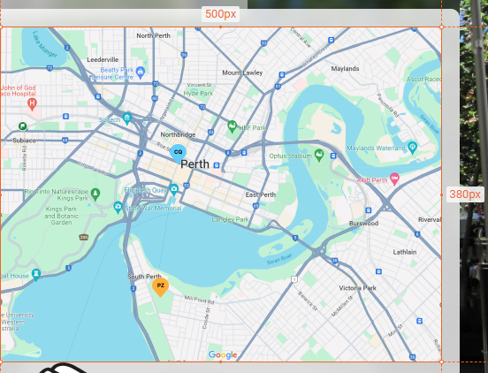

### Travrse Menu

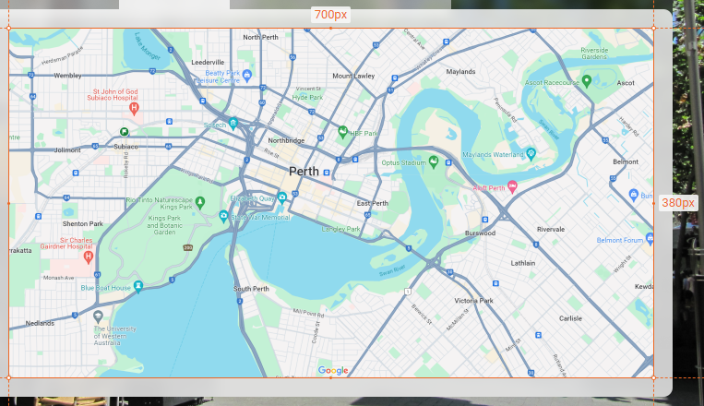

### Task *Bar*

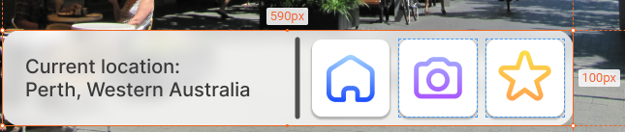

### Account Menu

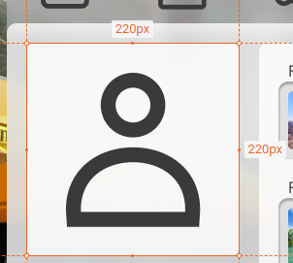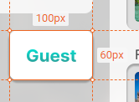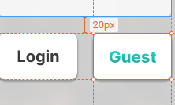

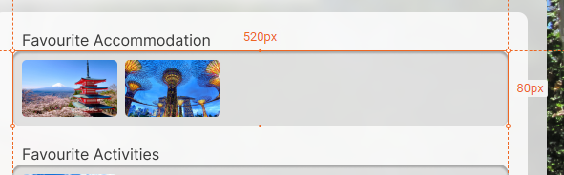

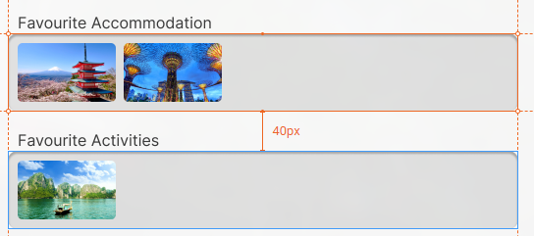

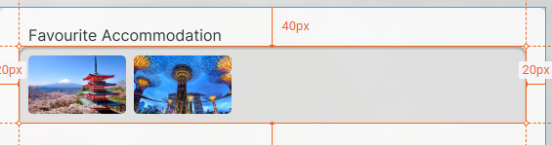

### Settings Menu

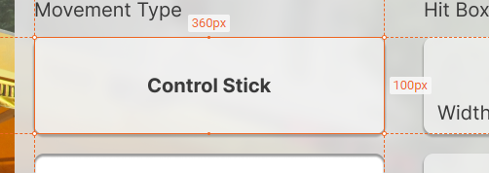

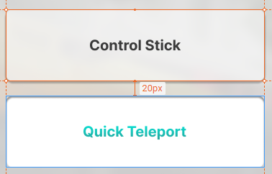

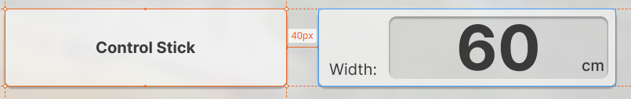

## Pop-up Menus

### Pre-Made Itinerary mode

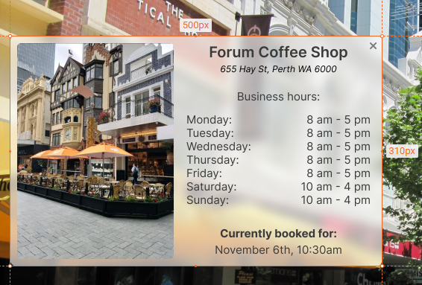

### Custom Itinerary Mode

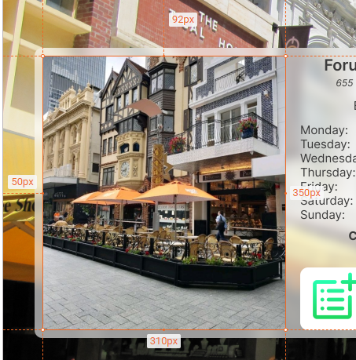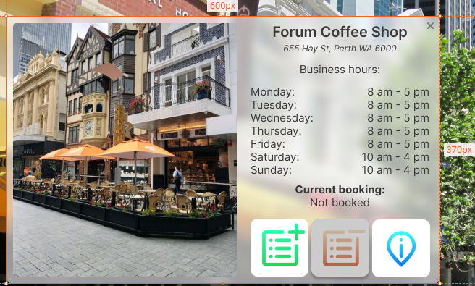

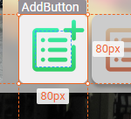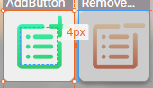

## Figma Navigation

Our Figma high fidelity prototype consists of both prototype A and B, alongside our improved final high fidelity as prototype C. To simulate operation on the application, select the Main Menu frame of prototype C, then select any of the tabs on the top to navigate to that screen and explore from there, with each major feature having its own tab.



References

& Appendix

13

# References

**Images used in high-fidelity prototype:**

Asian Inspirations. “Sights & Sounds in Singapore: 10 Places to Visit in Singapore,” August 9, 2019. <https://asianinspirations.com.au/experiences/sights-sounds-in-singapore-10-places-to-visit-in-singapore/>.

Digital Nomad World. “The Full Digital Nomad Guide to Bali, Indonesia,” December 17, 2020. <https://digitalnomads.world/city-guide/bali/>.

Dundas, Suzie. “What Is Japan Known For? | Celebrity Cruises.” Celebrity Current, March 12, 2021. <https://www.celebritycruises.com/blog/what-is-japan-known-for>.

Hernandez, Celeste. “¿Cuál Es La Mejor Época Para Viajar a La India?” LocalAdventures, October 2, 2023. <https://localadventures.mx/blog/cual-es-la-mejor-epoca-para-viajar-a-la-india/>.

kocdigitalgraphics1. “Dream Rooms: Part 1,” July 14, 2015. <https://kocdigitalgraphics1.wordpress.com/2015/07/14/dream-rooms-part-1/>.

Lonely Planet. “Vietnam Travel - Lonely Planet.” Lonely Planet, 2011. <https://www.lonelyplanet.com/vietnam>.

Matt, Nomadic. “13 Reasons Why You Need to Visit New Zealand in 2020.” Nomadic Matt’s Travel Site, April 12, 2018. <https://www.nomadicmatt.com/travel-blogs/great-reasons-to-visit-new-zealand/>.

Mozley, Fiona. “Why the U.K. Is T+L’s Destination of the Year for 2023.” Travel + Leisure, November 8, 2022. <https://www.travelandleisure.com/why-united-kingdom-destination-of-the-year-2023-6753037>.

Nast, Condé. “‘Fiji Is a Place That Drums on Your Senses, and Reminds You That You Are Alive’: What It’s Really like to Visit the World’s Friendliest Island.” CN Traveller, April 8, 2023. <https://www.cntraveller.com/article/finding-fiji-the-worlds-friendliest-island-nation>.

Wikipedia. “Hay Street,” December 28, 2019. https://en.wikipedia.org/wiki/Hay_Street.

# Appendix

## Appendix A: ChatGPT

**Prompt:** “Hey ChatGPT, my team, the Travrse team, is designing a virtual reality travel application called, Travrse. The purpose of Travrse is to provide users with a virtual reality application to explore travel destinations and plan and create itineraries through this one-stop application. We have chosen VR technology as it allows for users to have a more immersive experience when planning, and we believe that this will make travel planning more efficient, and reduce any differences in expectations as users will truly know what they will be experiencing. Travrse when designed, has been designed with the intention of being an assisting tool for travel agents at travel agencies to help their customers plan their ideal holiday. Thus the second interface would be for travel agents to assist the user wearing the headset, as well as the user’s itinerary to be for the travel agent to assist customers in bookings, etc.  A list of the functional requirements includes:

* The system will need to run at a consistent 120 fps.
* The system must have connections to travel agent systems to log and access itineraries.
* The system must contain virtual space renders of holiday locations at various times of year.
* The system must have an adjustable avatar to accurately replicate user dimensions.
* The system must provide functionality to provide extra information about points of interest.
* The system must have a 2D interface to allow planning and selection of itineraries and locations.
* The system must indicate potential hazards within the area of the holiday destination.

Can you please write an executive summary for Travrse to include in our design report?”

**Answer:**

[“**Executive Summary: Travrse**

Travrse is an innovative virtual reality (VR) travel application designed to revolutionize the way users explore, plan, and experience travel destinations. With a focus on immersion and efficiency, Travrse offers a comprehensive platform that seamlessly integrates VR technology with travel planning functionalities.

At the core of Travrse is the commitment to providing users with an immersive experience, ensuring that they can truly visualize and understand their chosen destinations before making any commitments. By leveraging VR technology, Travrse eliminates discrepancies in expectations and empowers users to make informed decisions about their travel experiences.

**Key features of Travrse include:**

1.**Immersive Exploration**: Users can explore virtual renditions of holiday destinations at various times of the year, offering a dynamic and lifelike representation of each location.

2. **Personalized Avatar**: Travrse allows users to create adjustable avatars that accurately replicate their dimensions, enhancing the immersive experience and personalization of the platform.

3. **Comprehensive Itinerary Planning**: The platform offers a 2D interface for planning and selecting itineraries and locations, providing users with a user-friendly and intuitive tool to organize their travels.

4. **Integration with Travel Agent Systems**: Travrse seamlessly connects with travel agent systems, enabling users to log and access their itineraries while also facilitating collaboration with travel agents for bookings and assistance.

5. **Enhanced Information**: Users can access detailed information about points of interest within each destination, empowering them to make informed decisions and enriching their travel experiences.

6. **Safety Features**: Travrse incorporates features to indicate potential hazards within the area of the holiday destination, prioritizing user safety and well-being.

In addition to catering to individual travellers, Travrse also serves as a valuable tool for travel agents at travel agencies. By providing a second interface specifically designed for travel agents to assist users, Travrse enhances the efficiency and effectiveness of travel planning processes, ultimately delivering a superior customer experience.

With a commitment to running at a consistent 120 frames per second (fps), Travrse ensures a smooth and seamless user experience, setting a new standard for VR travel applications.

In conclusion, Travrse represents the future of travel planning, offering a groundbreaking platform that combines immersive technology with comprehensive functionalities to empower users and revolutionize the travel industry.”]

## Appendix B: Expert Review

Review conducted by our team for another group.

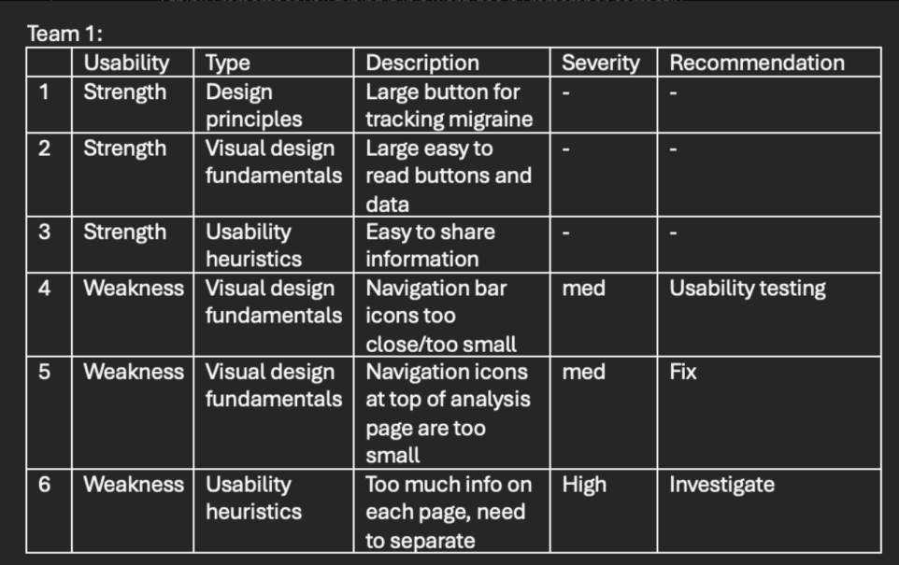

## Appendix C: Contribution Table

|  |  |  |  |  |
| --- | --- | --- | --- | --- |
|  | Management | Design | Interactivity and Editing | Data analyst |
| Justin P |  |  |  |  |
| Tyler M |  |  |  |  |
| Kevin K |  |  |  |  |
| Caio S |  |  |  |  |

## Appendix F: Figma Files

* Travrse HiFi Prototype.fig
* Travrse LoFi Prototype.fig